

Online grocery delivery: **Fresh Basket: Scalable E-commerce Platform Deployment with Flask on AWS EC2 and RDS**

**By**

**CHALLA. YASWANTH**

218x1a4211@khitguntur.ac.in

**KAPAROUTHU. CHANDANA SREE**

218x1a4227@khitguntur.ac.in

**KONDURU. CHANDRA SEKHAR**

228x5a4205@khitguntur.ac.in

**BAKKATHATLA. BALAYESU**

218x1a4245@khitguntur.ac.in

**Fresh Basket: Scalable E-commerce Platform Deployment with Flask on AWS EC2 and RDS**

**Project Description:**

The "Fresh Basket" project involves developing and deploying a scalable e-commerce platform for selling vegetables and fruits. The platform uses Flask for backend development, AWS EC2 for hosting, and Amazon RDS for database management. This cloud-native solution ensures high availability, scalability, and efficient management of the platform’s operations. The project demonstrates how leveraging AWS services can create a robust infrastructure for managing user interactions, product catalogs, and order processing in a seamless manner.

**Scenario 1: Scalable Web Applications for Online Retail**

In online retail scenarios, AWS EC2 provides a scalable infrastructure that can adapt to varying levels of customer traffic. For example, an online electronics store could use EC2 to handle peak shopping periods like Black Friday, ensuring that the website remains responsive and available. By leveraging Flask for backend development, the store can manage user sessions, product catalogs, and order processing efficiently. This setup allows the retail platform to grow and handle increased user demand without performance degradation.

**Scenario 2: Efficient Database Management for SaaS Platforms**

For Software-as-a-Service (SaaS) platforms, Amazon RDS offers a managed database solution that simplifies operations and enhances performance. Consider a SaaS application for project management where RDS handles user data, project details, and task histories. By utilizing RDS with MySQL, the platform benefits from automated backups, easy scaling, and high availability. This ensures that the application can support a growing user base while maintaining data integrity and reliability.

**Scenario 3: Secure and Scalable Hosting for Health Tech Applications**

In health tech applications, AWS EC2 can provide a secure and scalable environment for hosting applications that manage patient records, appointment scheduling, and telemedicine services. By integrating IAM (Identity and Access Management) for secure access control, the platform ensures that only authorized personnel can access sensitive health data. EC2’s scalability allows the application to handle varying levels of user activity and data processing needs, supporting a high level of performance and security.

**Technical Diagram:**

**ER Diagram:**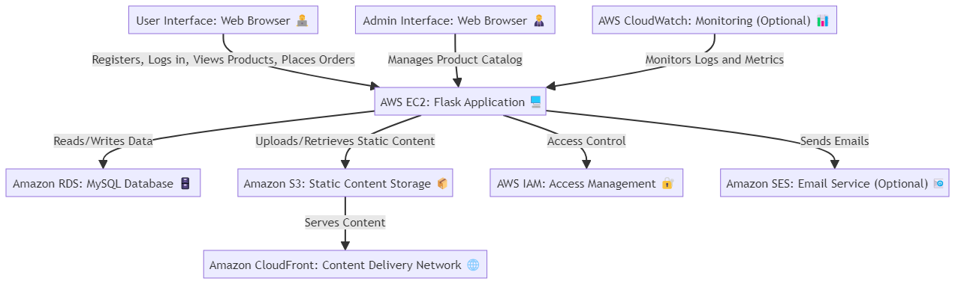

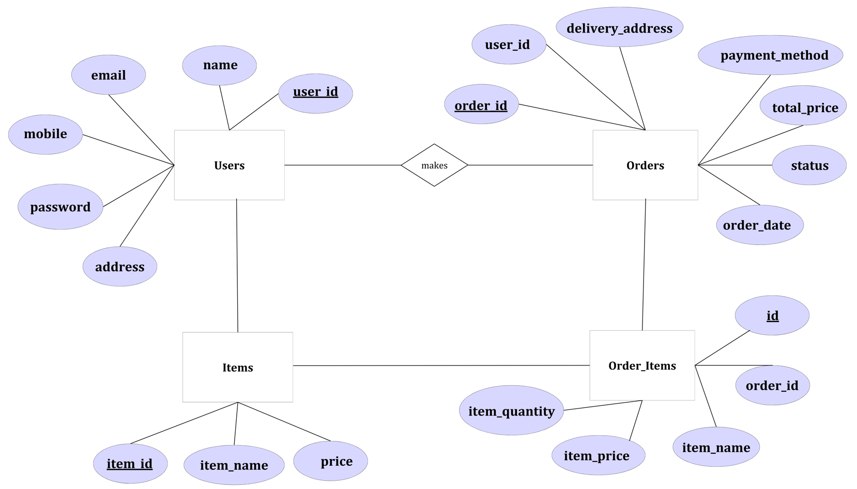

**Pre-requisites:**

### 1. AWS Account Setup: [https://youtu.be/CjKhQoYeR4Q?si=ui8Bvk_M4FfVM-D](https://youtu.be/CjKhQoYeR4Q?si=ui8Bvk_M4FfVM-Dh)h

### 2. Understanding of IAM: <https://youtu.be/gsgdAyGhV0o?si=3qg-bULgkD4LXNvR>

### 3. Knowledge of Amazon EC2 :<https://youtu.be/8TlukLu11Yo?si=MUj0nEAOESRhHUIz>

4. Mobaxtream : <https://youtu.be/dvoU2SKG6oA?si=Hs8Pu4Crry5-BRrD>

5. RDS : <https://www.youtube.com/live/MPau9c7PT74?si=A8OK-zFGbSKkAFWN>

6. MySQL WorkBench: <https://youtu.be/wALCw0F8e9M?si=ovMF9qMx5rLxaznB>

**Project WorkFlow:**

**1. Project Initialization:**

* Define objectives, scope, and KPIs for deploying the FreshBasket e-commerce platform.
* Set up the AWS environment, including EC2 instance configuration and RDS setup.
* Outline the use of Flask for backend development and integration of AWS services.

**2. EC2 Instance Creation:**

* Launch an EC2 instance to host the FreshBasket application.
* Select the appropriate instance type based on expected traffic and resource requirements.

**3. RDS Configuration:**

* Set up Amazon RDS for database management with MySQL.
* Configure database instances, including security settings and access controls.

**4. Flask Application Deployment:**

* Develop and deploy the FreshBasket application using Flask.
* Transfer application files to the EC2 instance and configure the environment.

**5. Web Server Setup:**

* Install and configure a web server (e.g., Apache, Nginx) on the EC2 instance.
* Configure the server to properly handle Flask application requests.

**6. Testing and Optimization:**

* Test the application for functionality, performance, and security.
* Optimize server settings, database configurations, and application performance.

**7. Monitoring and Maintenance:**

* Implement monitoring tools (e.g., AWS CloudWatch) to track application performance and uptime.
* Regularly update and maintain the application and server to ensure ongoing reliability and scalability.

**Milestone 1: AWS Account Setup and Login**

* **Activity 1.1: Create AWS Account**
  + Sign up for an AWS account and configure billing settings.

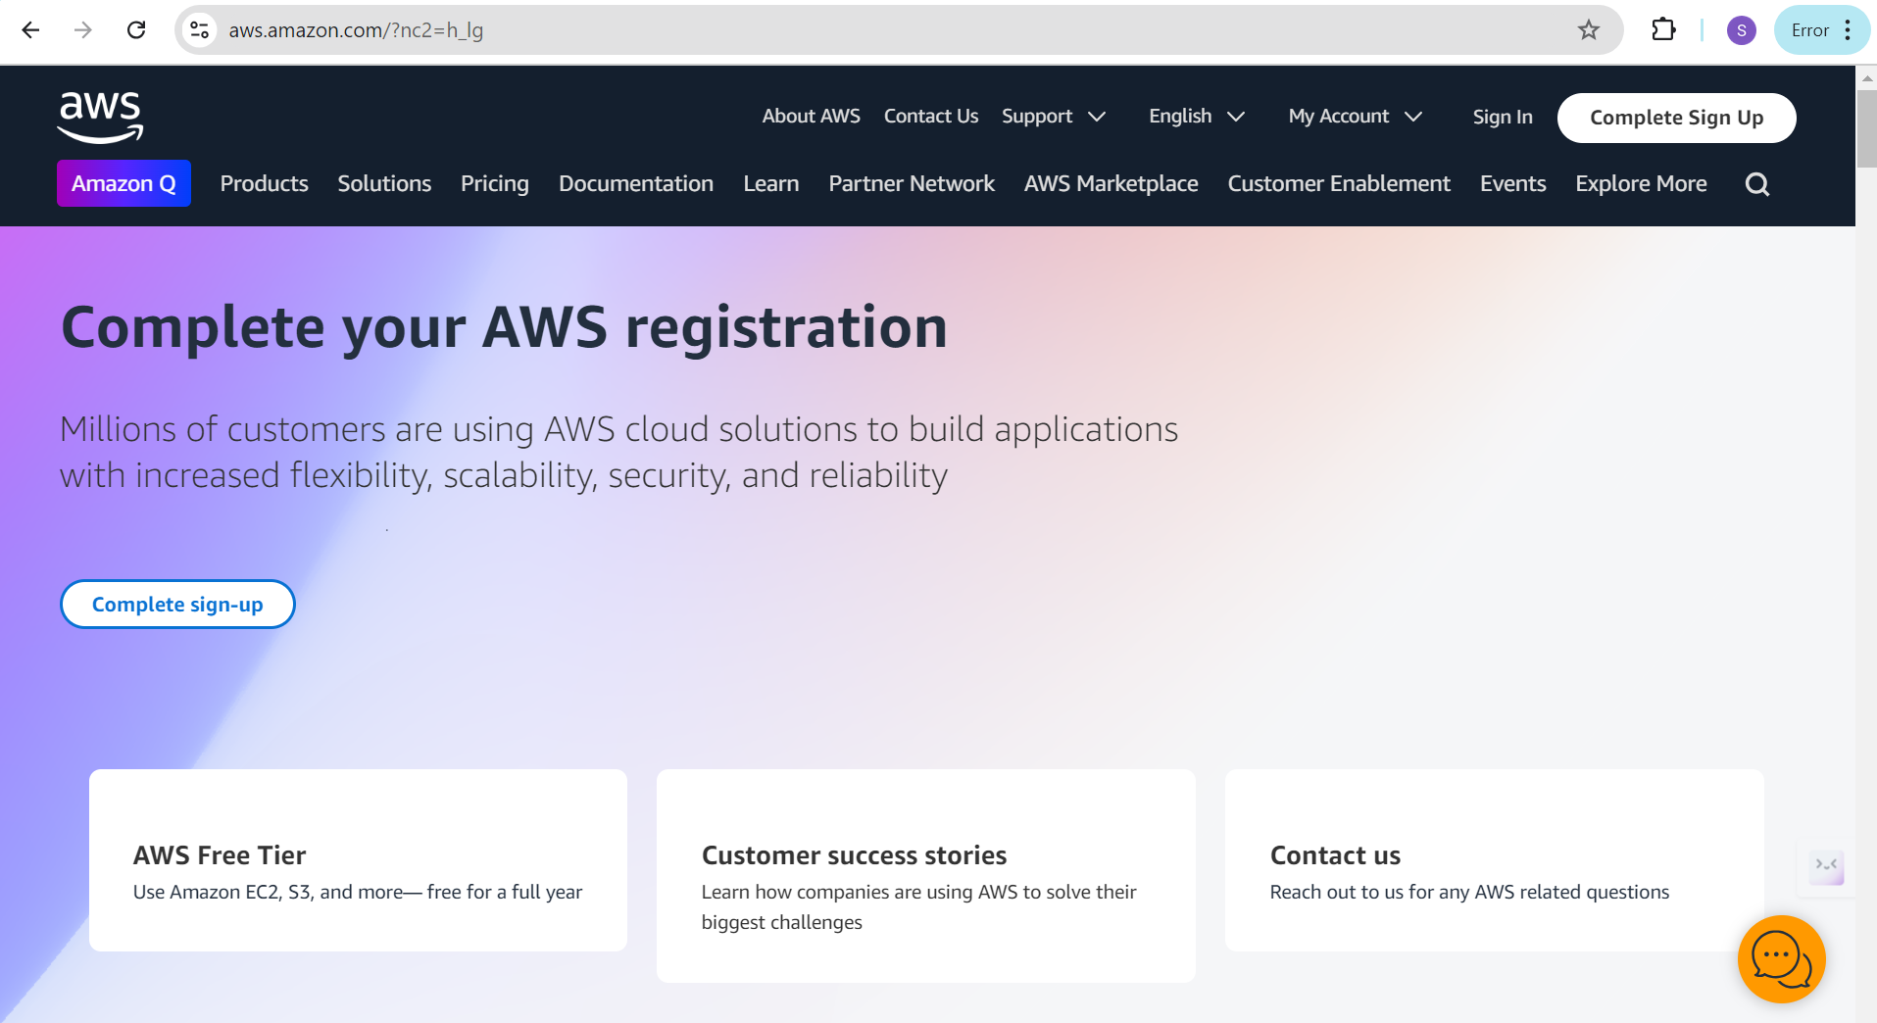

* **Activity 1.2: Log in to AWS Management Console**
  + Access the AWS Management Console using your login credentials.

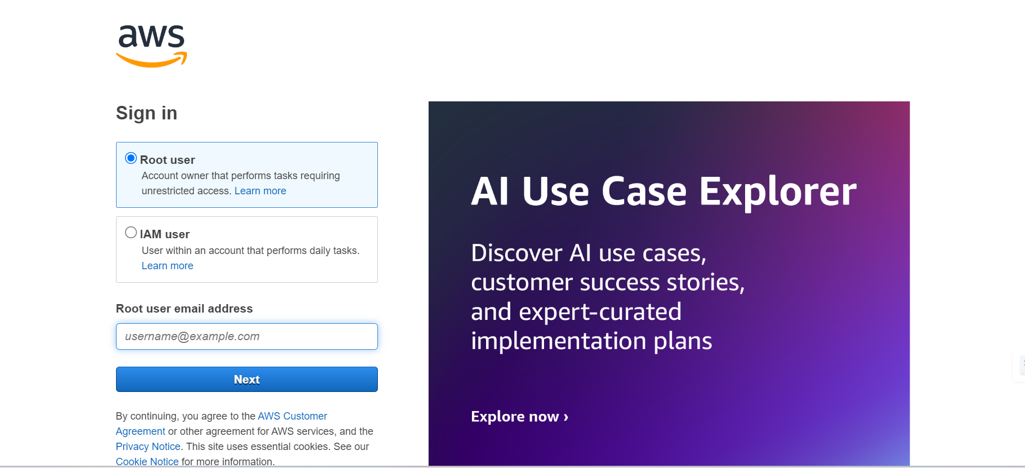

**Milestone 2: RDS Database Creation and Setup**

* **Activity 2.1: Create an RDS Instance**
  + Choose the RDS service from the AWS Management Console.

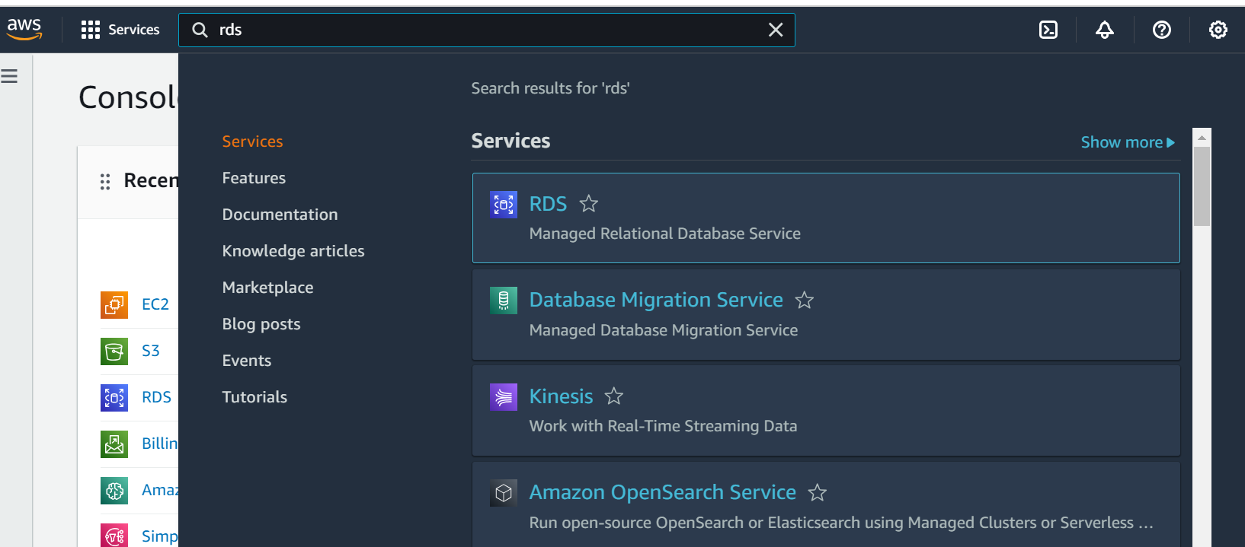

* + Select MySQL as the database engine, configure the instance settings (e.g., storage, instance class), and launch the RDS instance.

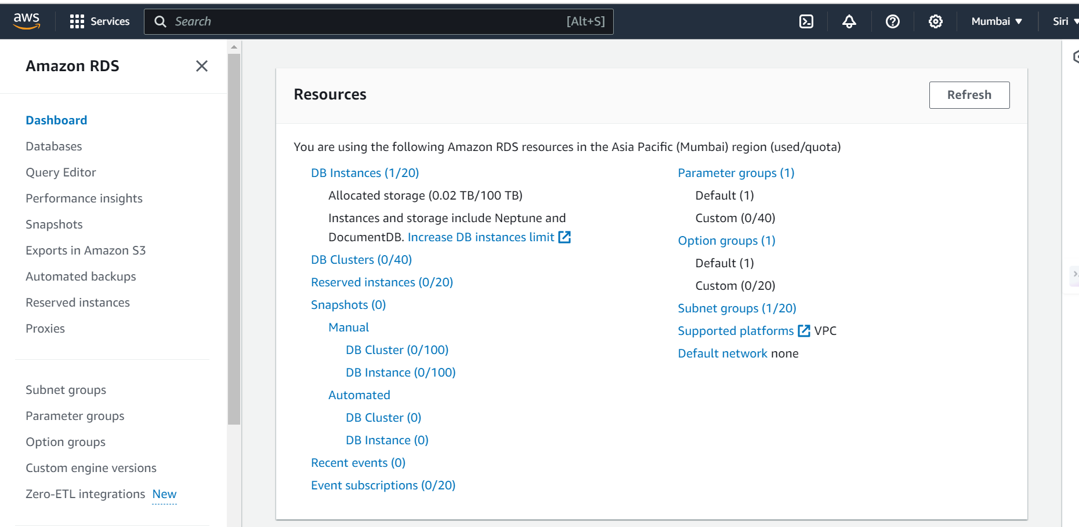

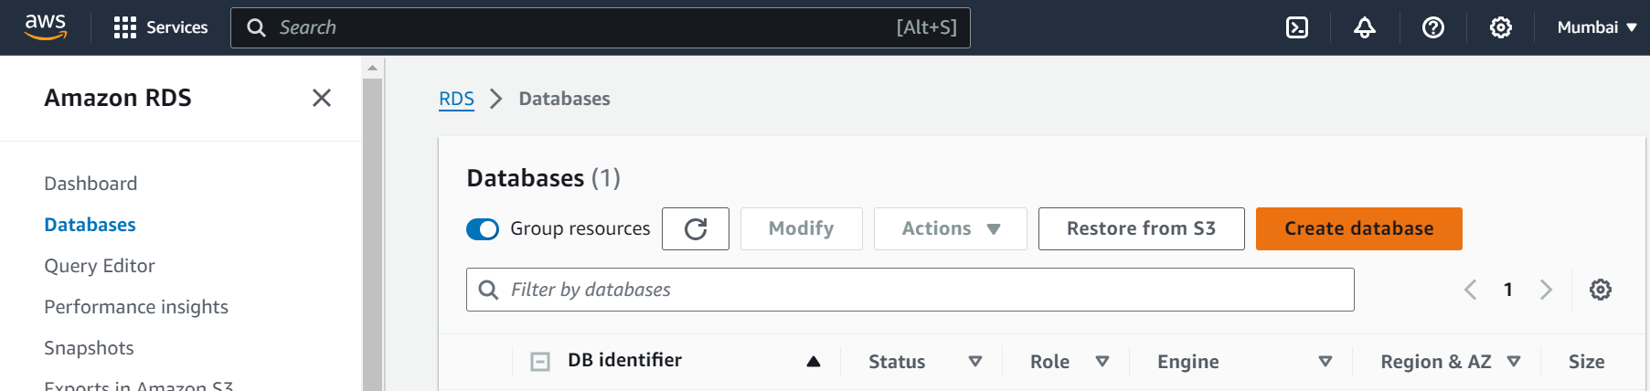

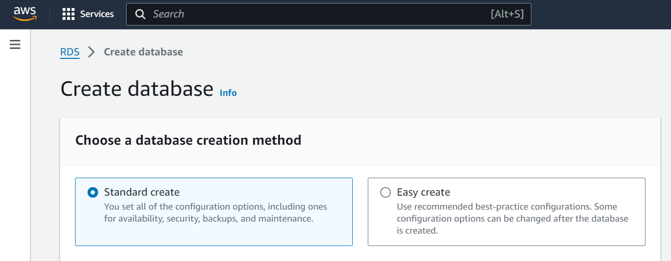

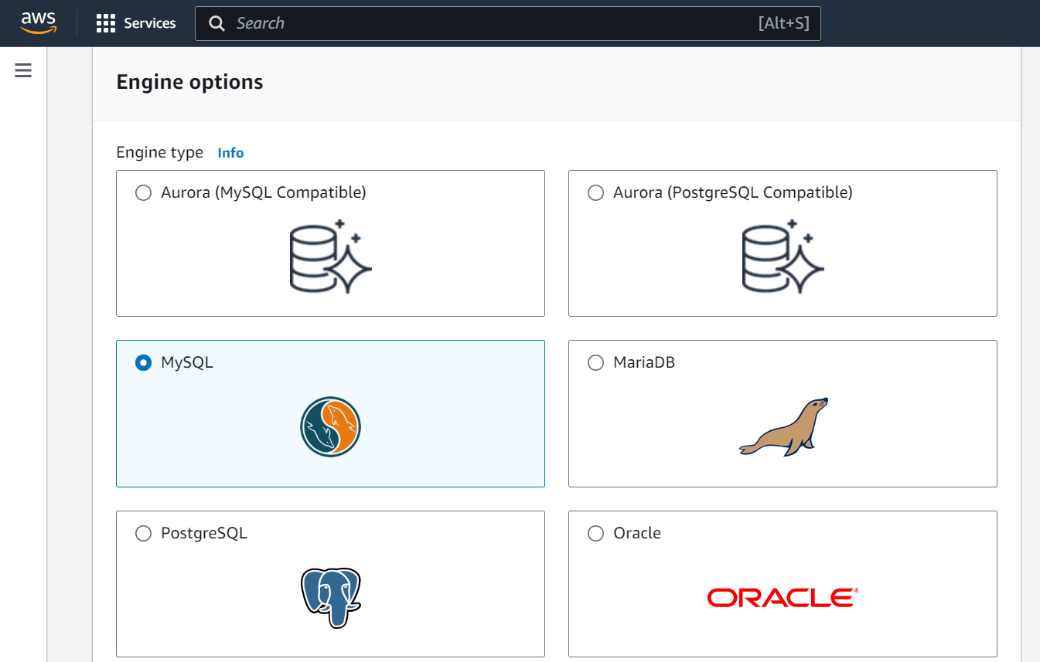

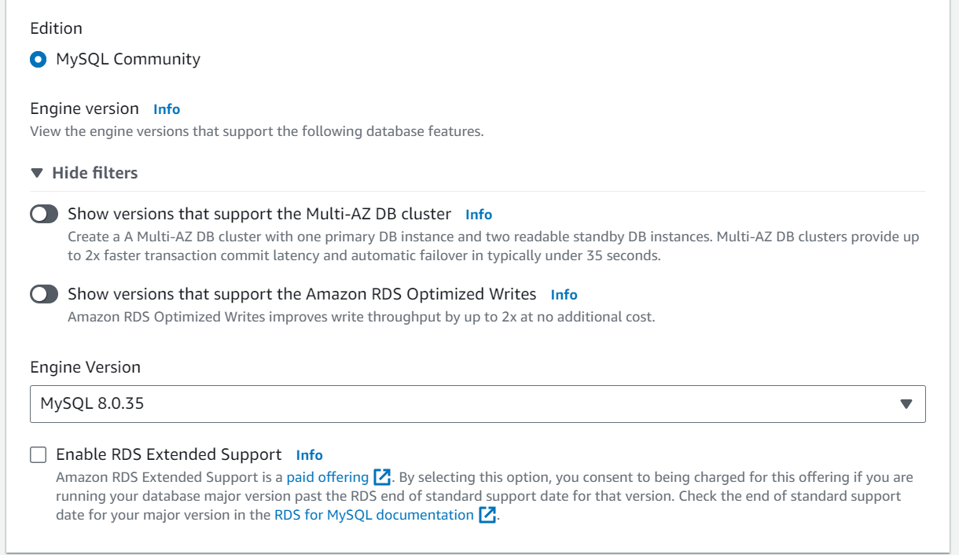

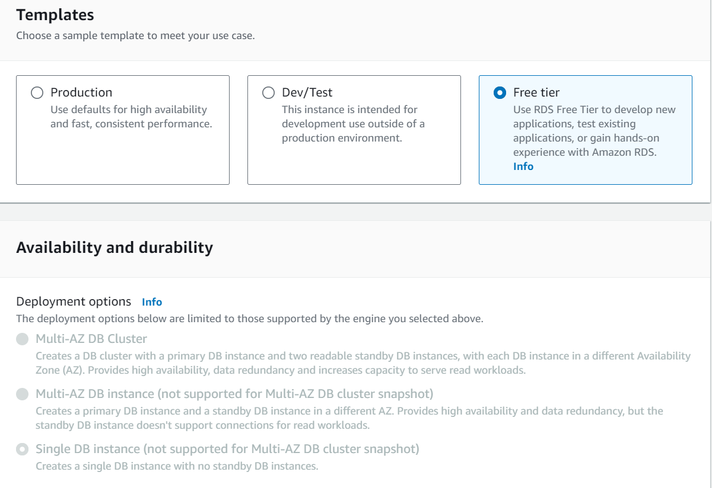

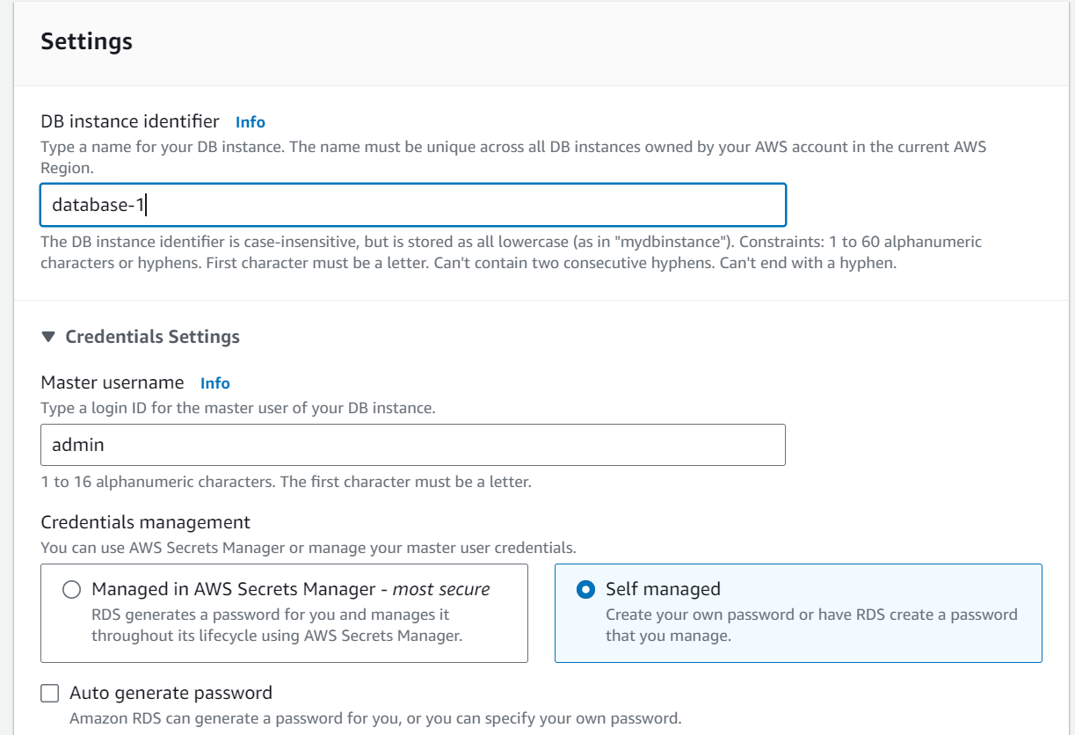

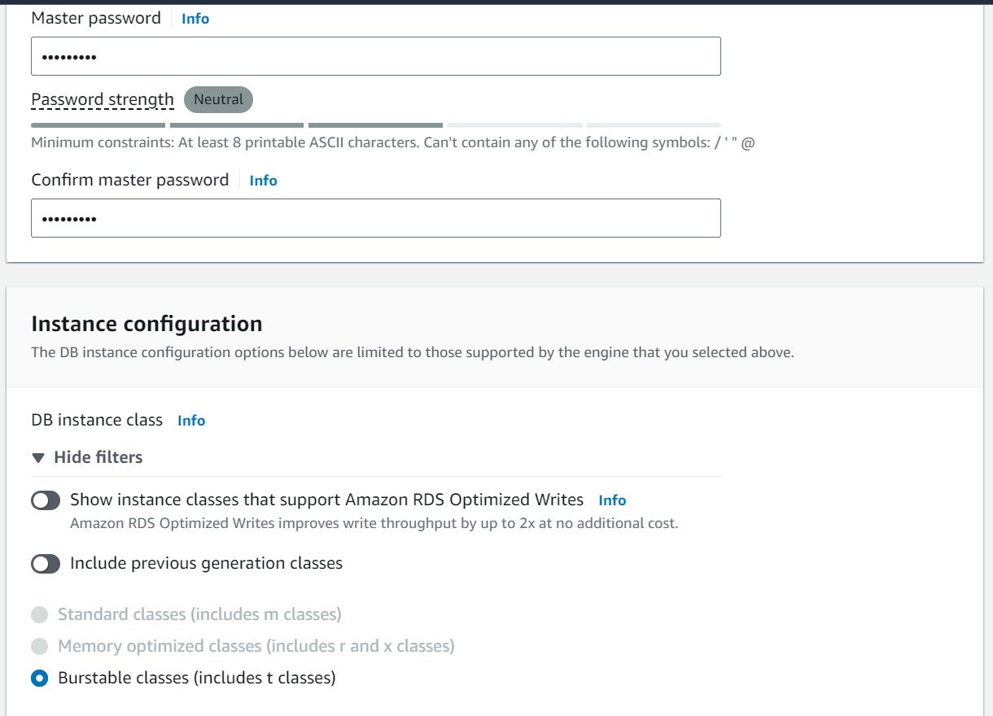

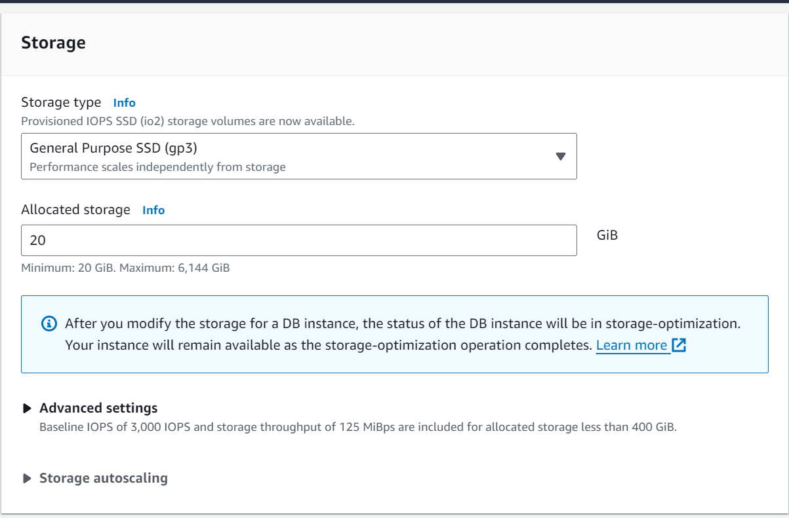

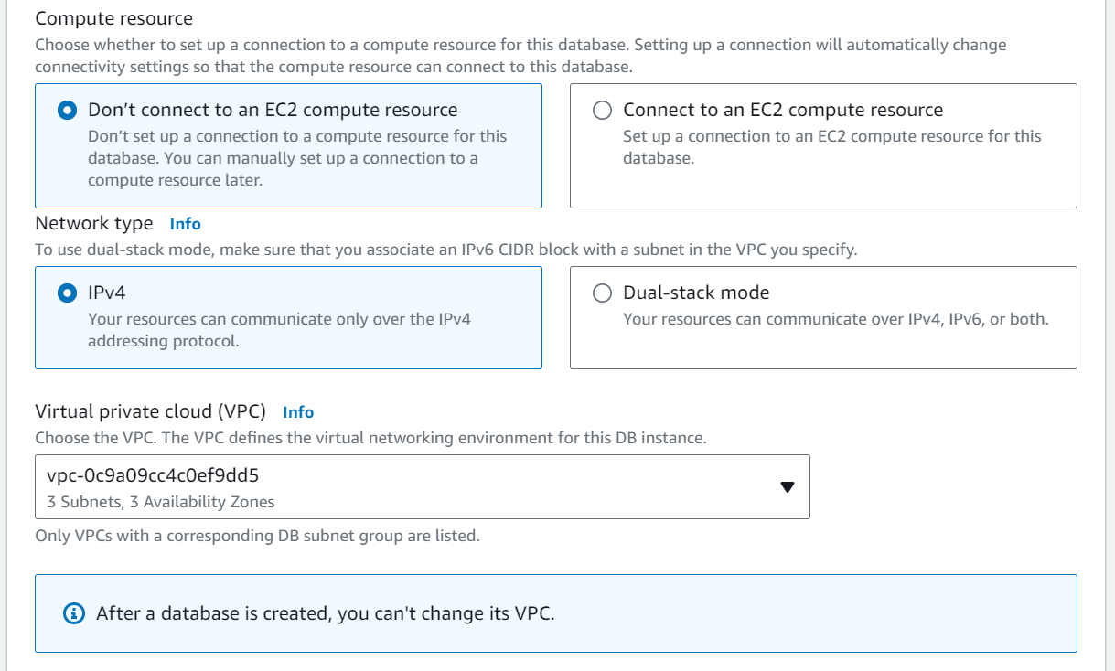

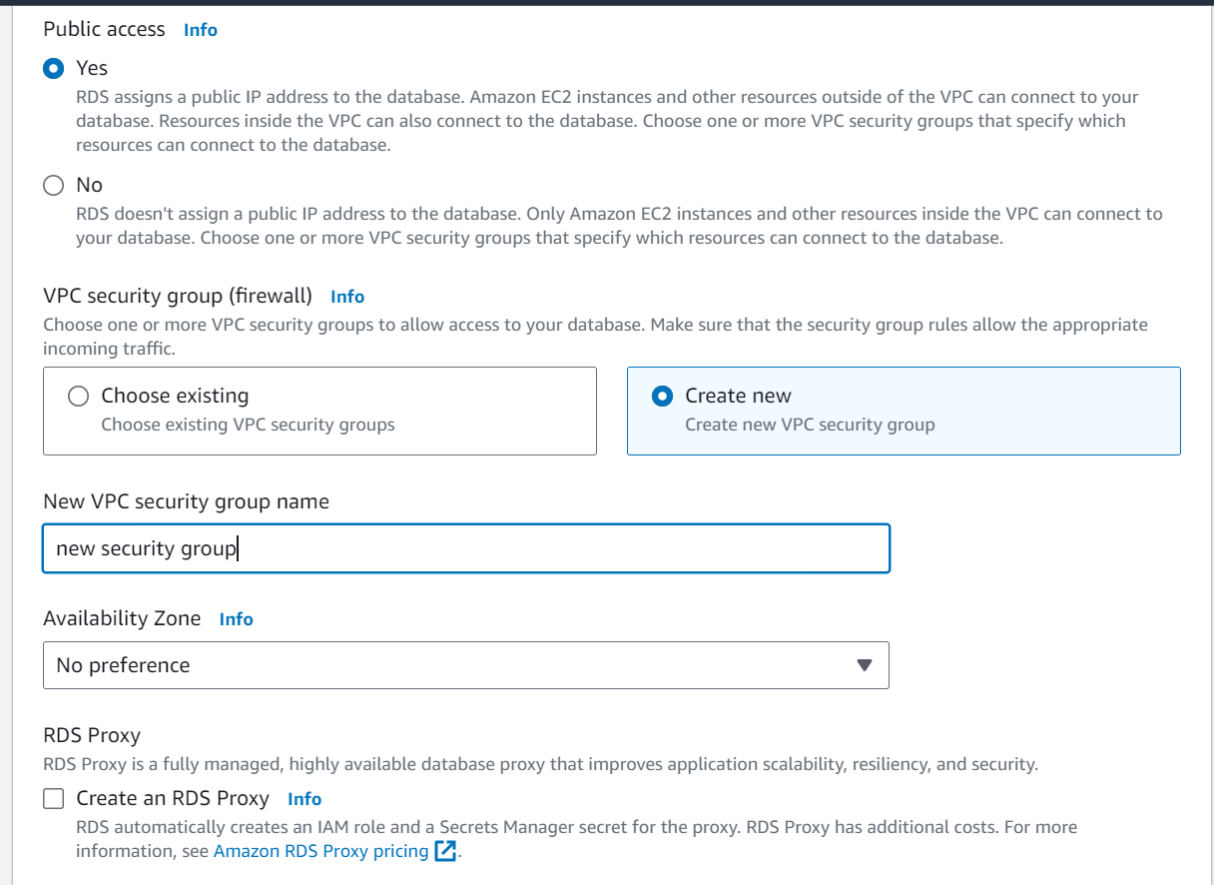

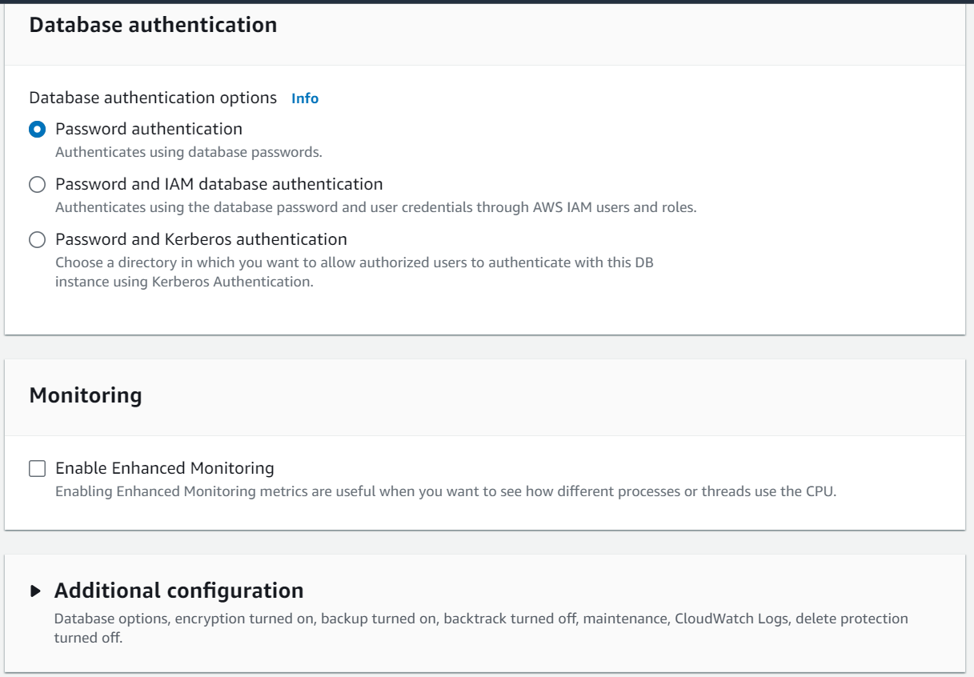

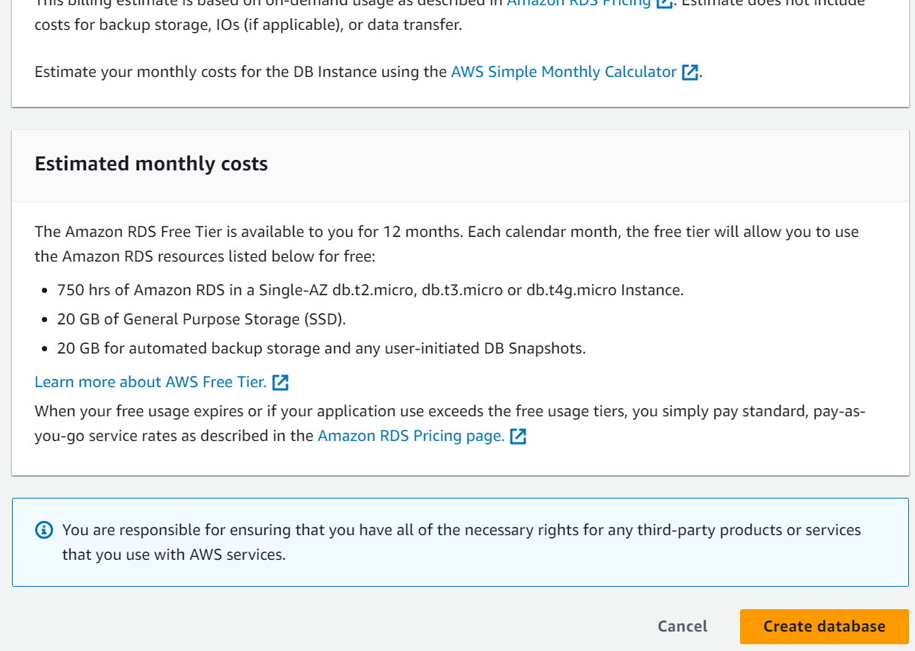

* **Activity 2.2: Configure Database Access**
  + Set up security groups, create database credentials, and configure access policies to ensure secure connectivity to the database.
* **Activity 2.3: Install MySQL Workbench**
  + Download and install MySQL Workbench on your local machine for database management.

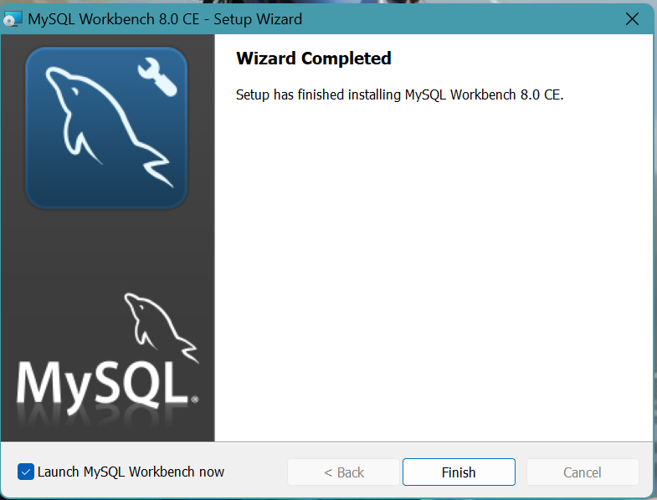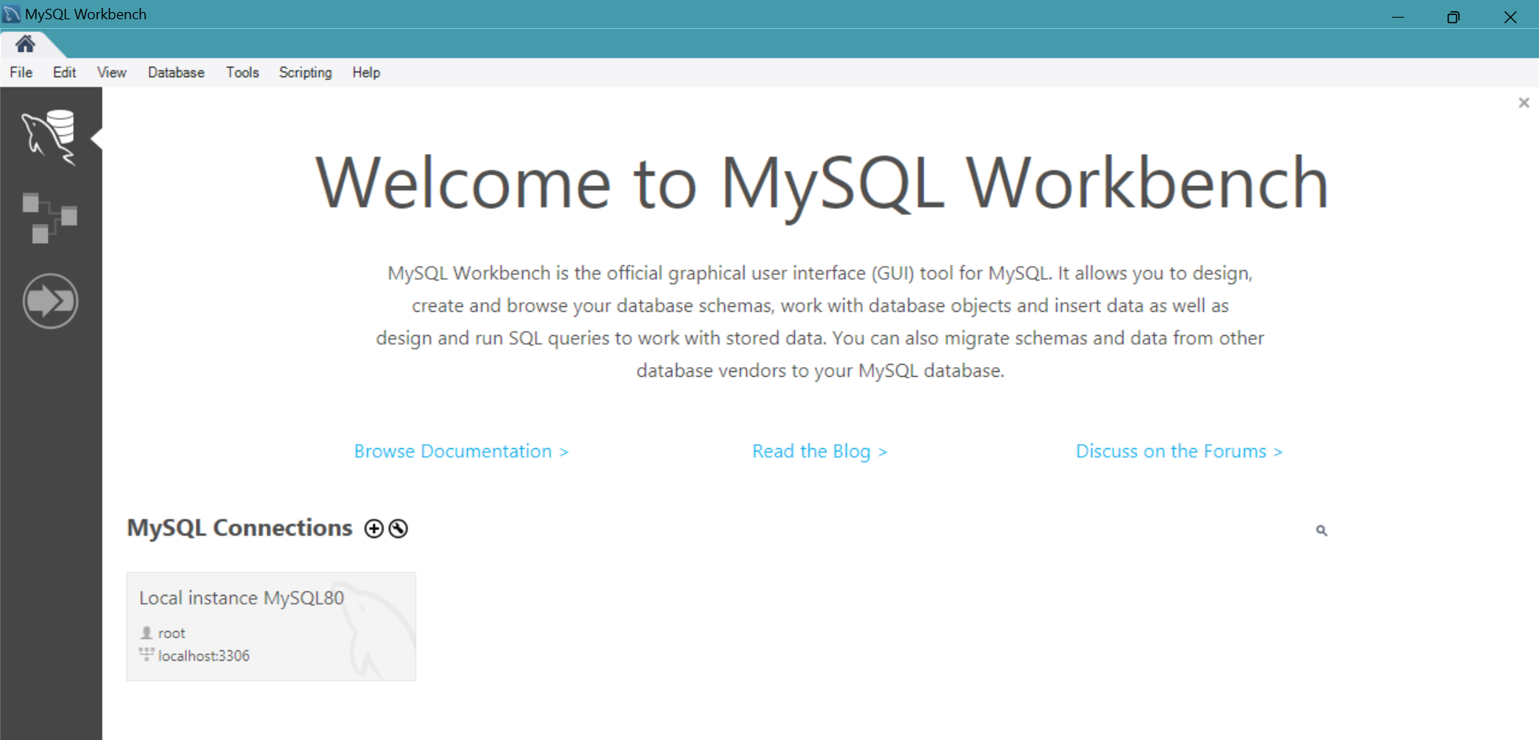

* + Connect to the RDS instance via MySQL Workbench using the endpoint and credentials from AW
  + 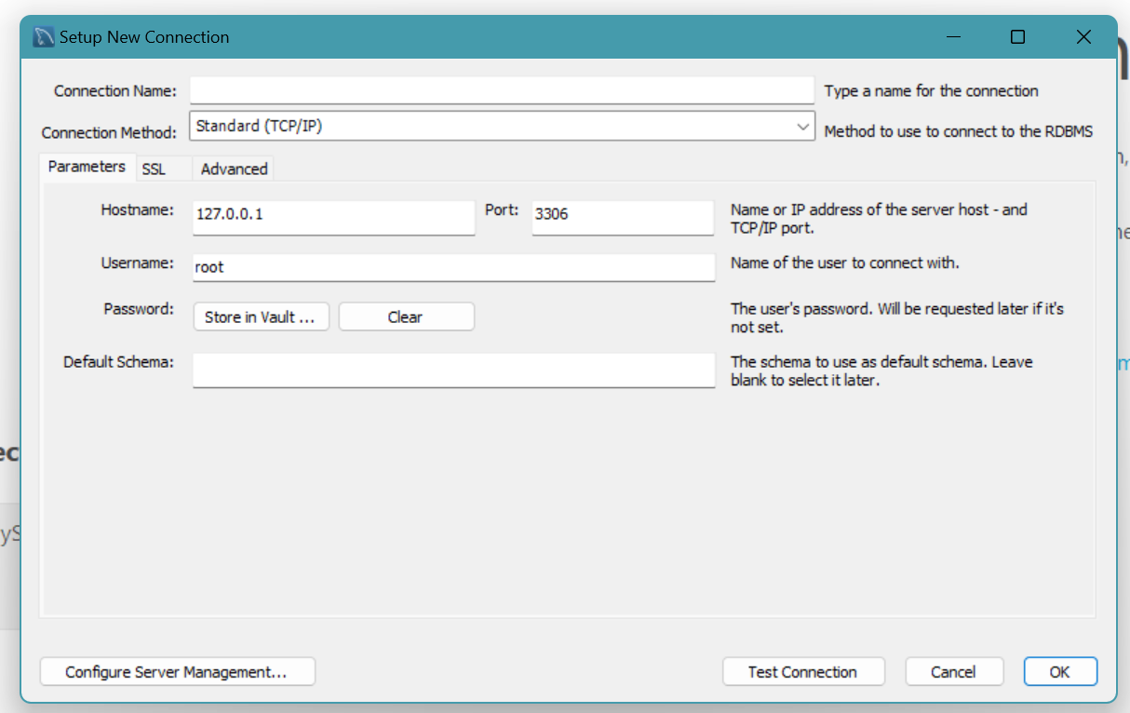
* Give a connection name.
* Copy the endpoint from the RDS database that is created in AWS and paste it in **Hostname.**
* Write the username and enter the password , then click on **Test Connection**.
* Once the connection is successful, you’ll be welcomed with this interface

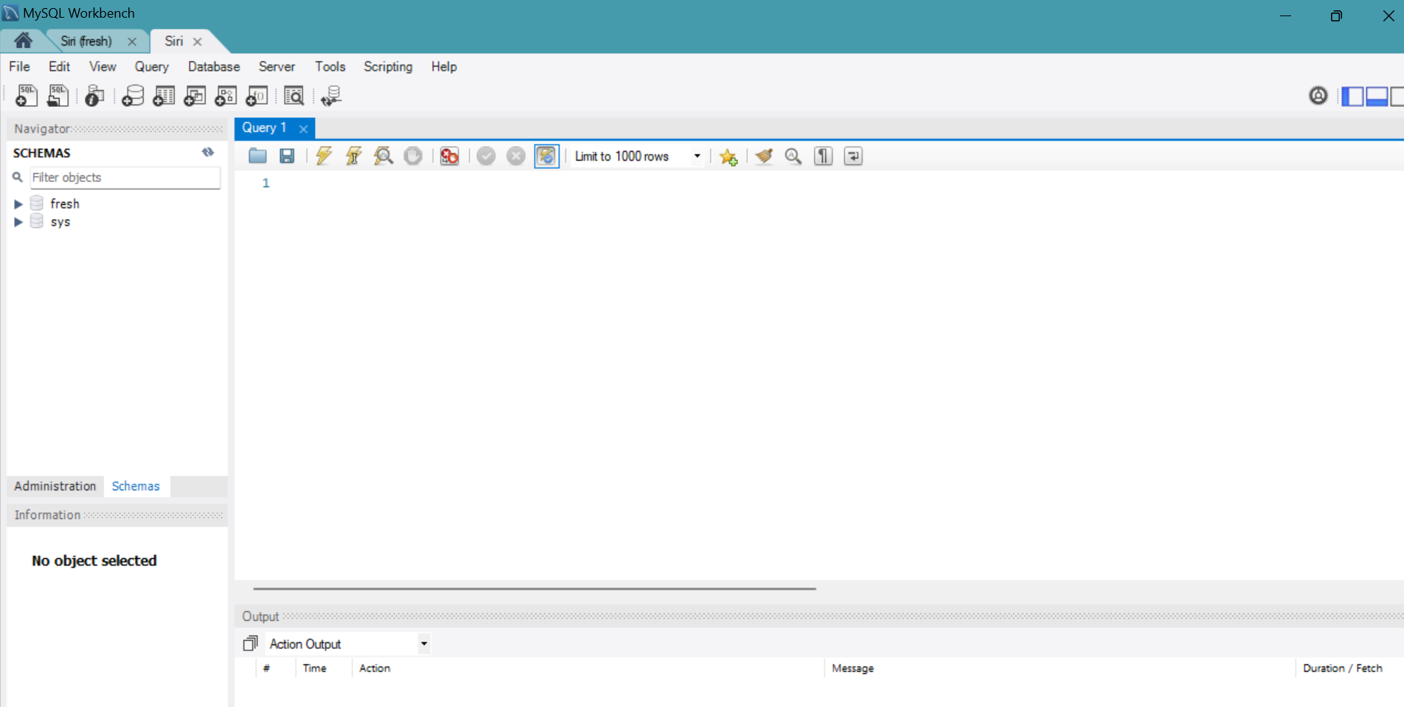

**Activity 2.4:** Create the Database and the tables which are required.

* **Create a basic database schema for an e-commerce platform**

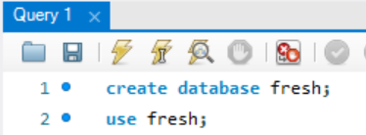

**Tables Created :**

1. **users**:

* Stores user information such as name, mobile, email, password, and address.
* Each user has a unique ID (id), which is the primary key.

Columns:

* id (Primary Key)
* name, mobile, email, password, address

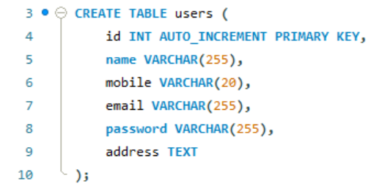

1. **items**:

* Contains available products with fields like item_name and price.
* Each item has a unique identifier item_id and the auto-increment starts from 111.

Columns:

* item_id (Primary Key)
* item_name, price

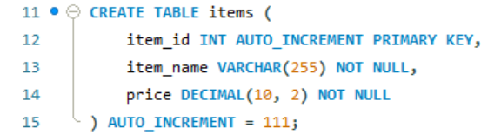

1. **orders**:

* Holds order details including the user_id (foreign key referencing the users table), delivery information, payment method, and total price.
* Each order is assigned a status (e.g., "Yet to Ship", "Shipped") and an order_date.

Columns:

* id (Primary Key)
* user_id (Foreign Key), delivery_address, payment_method, total_price, status, order_date

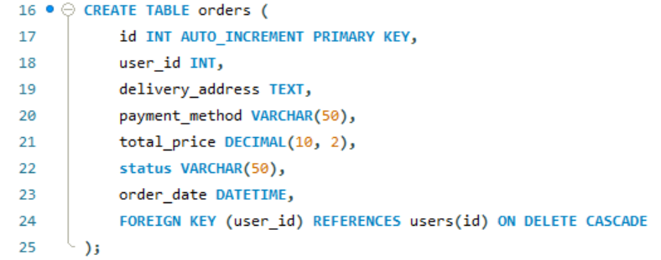

1. **order_items**:

* Stores details of each item in an order. For each order (order_id), the table records the item_name, item_price, and item_quantity.
* The order_id references the orders table.

Columns:

* id (Primary Key)
* order_id (Foreign Key), item_name, item_price, item_quantity

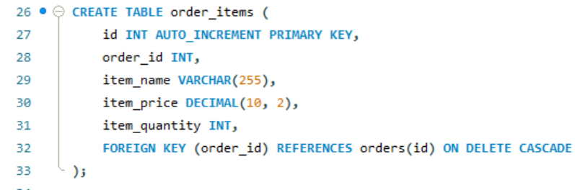

### Data Operations:

1. **Data Insertion into items**: We inserted multiple rows into the items table, representing products available in the shop (like Apple, Banana, etc.) along with their prices.

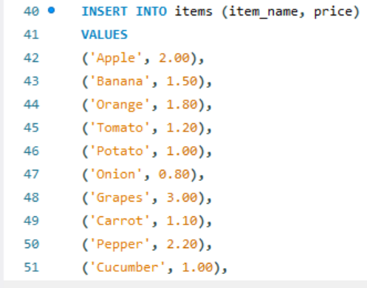

**2. Data Retrieval**: We retrieved data from each table to view the stored information, including user details, available items, and orders.

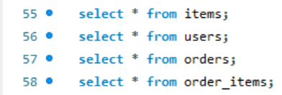

**Milestone 3: Frontend Development and Application Setup**

* **Activity 3.1: Build the Frontend**
  + Develop HTML, CSS, and Python-based Flask application files for FreshBasket’s frontend interface.

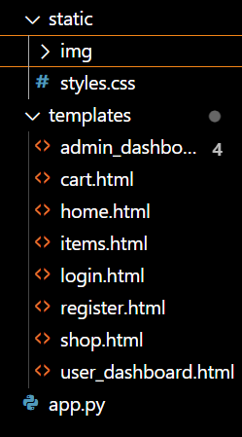

* **Activity 3.2: Integrate Application with RDS**
  + Connect app.py (Flask application) to the MySQL RDS database by configuring database connection settings and verifying connectivity.

**Description of the code :**

1. **Flask App Initialization**: Initializes a Flask application with secret key for sessions.

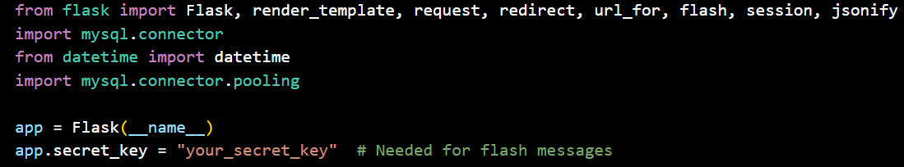

1. **Database Configuration**: Configures MySQL RDS with connection pooling for efficient database access.

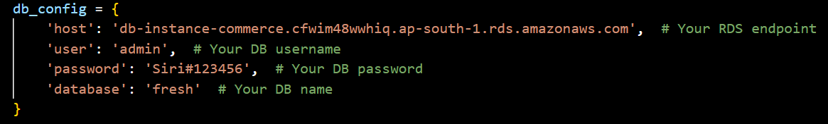

1. **Connection Pool**: Uses MySQL connection pooling to handle multiple database connections.

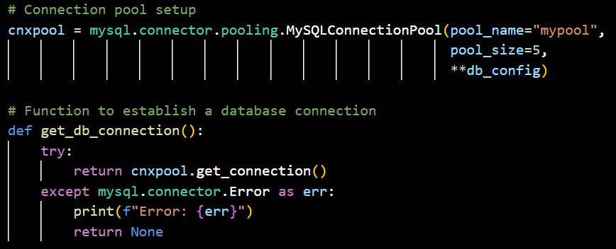

1. **Home Route**: Renders the home page template when the root URL is accessed.
2. **Register Route (GET/POST)**: Handles user registration, inserts user data into the database.

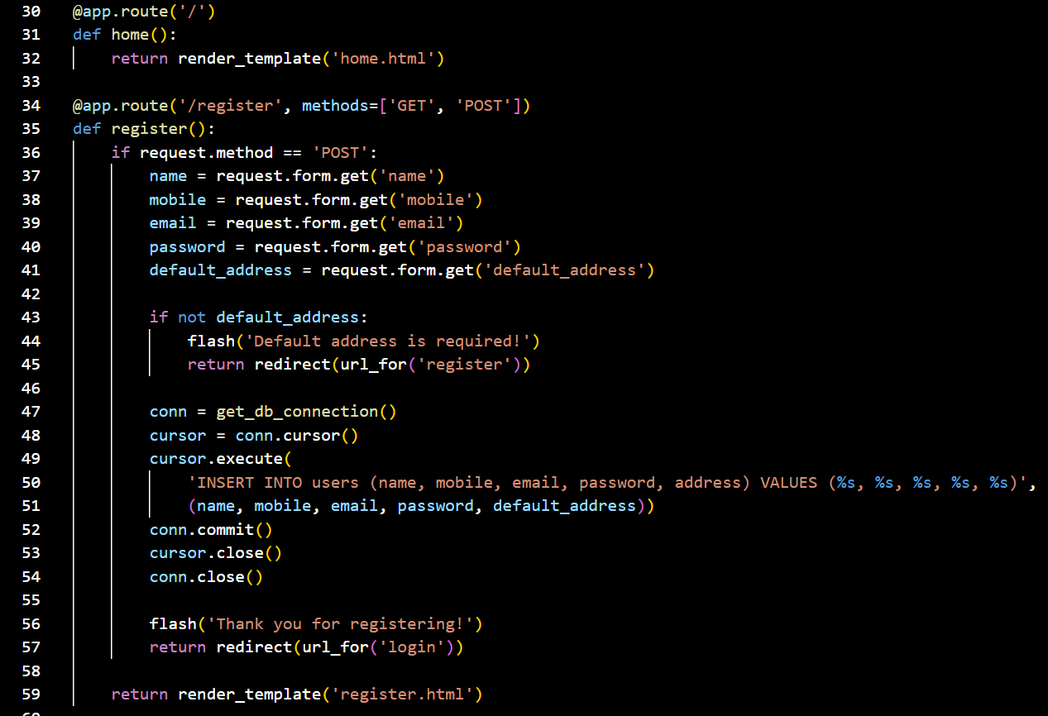

1. **Login Route (GET/POST)**: Authenticates user with email and password, creates session on success.

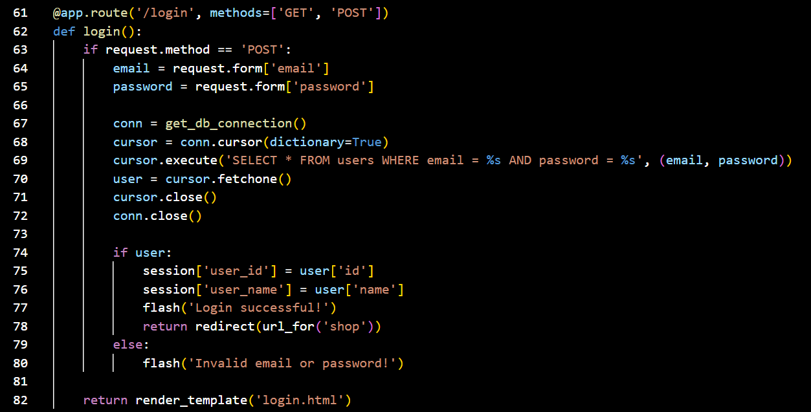

1. **Shop Route**: Renders the shop page, showing available products to logged-in users.
2. **Add to Cart (POST)**: Adds selected items to the user's session-based shopping cart.

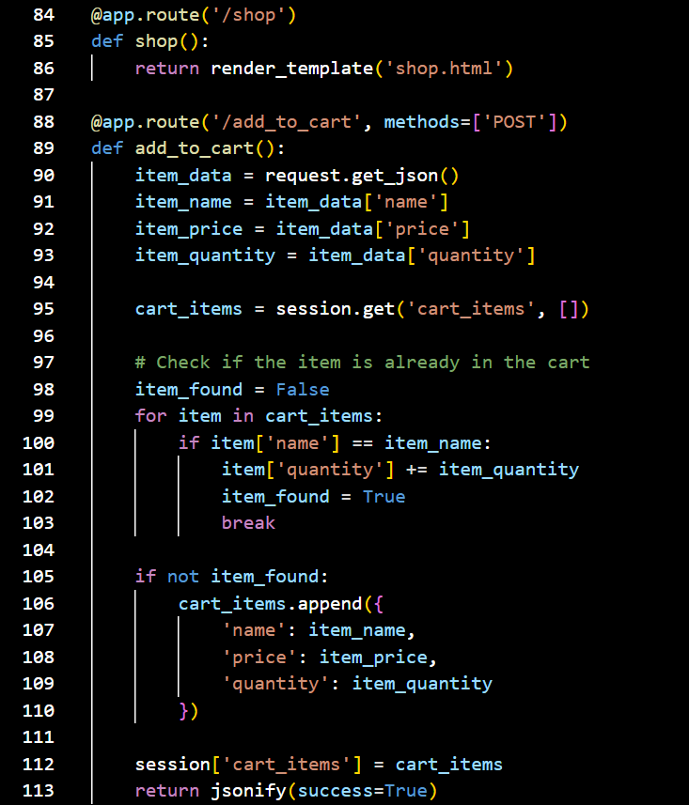

1. **Items Route (GET/POST)**: Displays available items and allows adding them to the shopping cart.

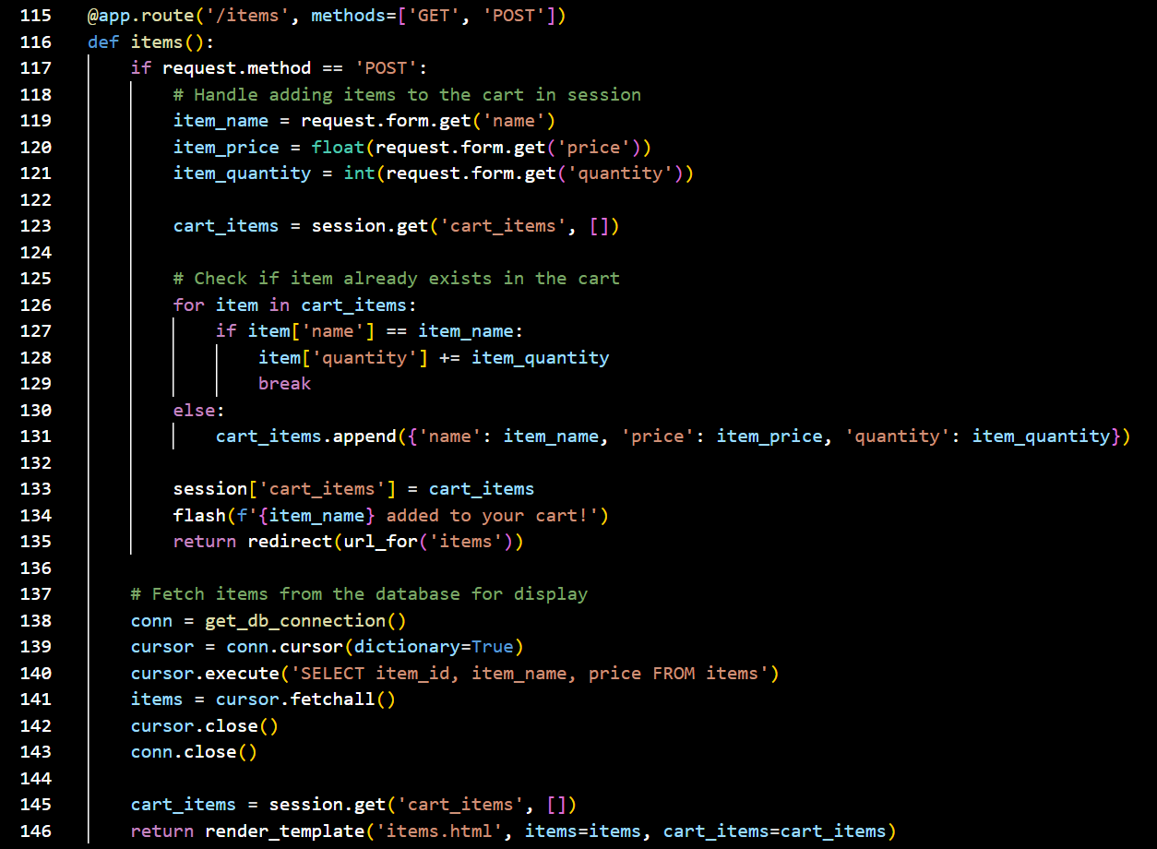

1. **Place Order Route (POST)**: Places an order, inserts order and item data into the database.

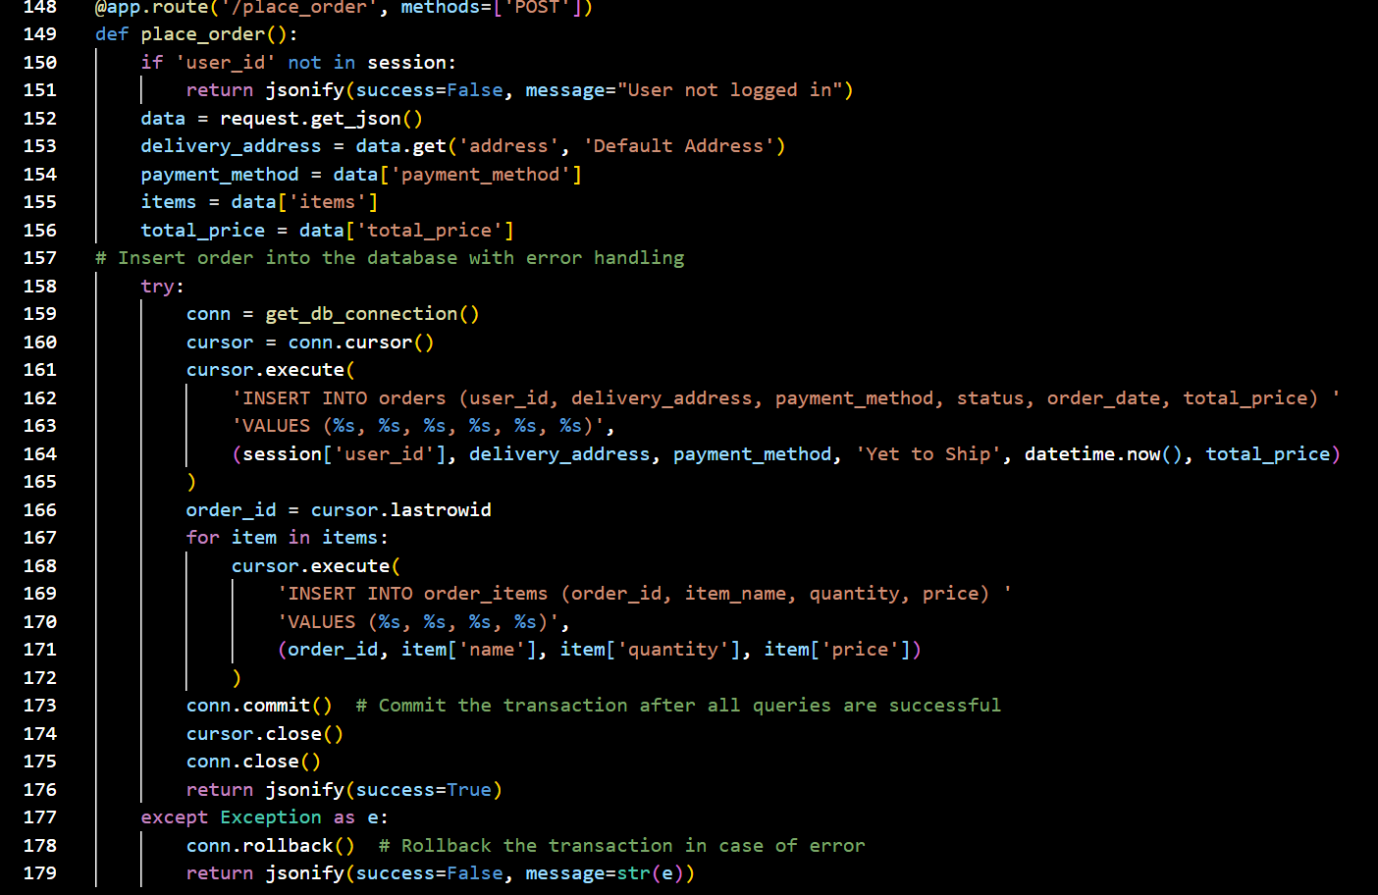

1. **User Dashboard Route**: Displays user-specific order history with item details and statuses.

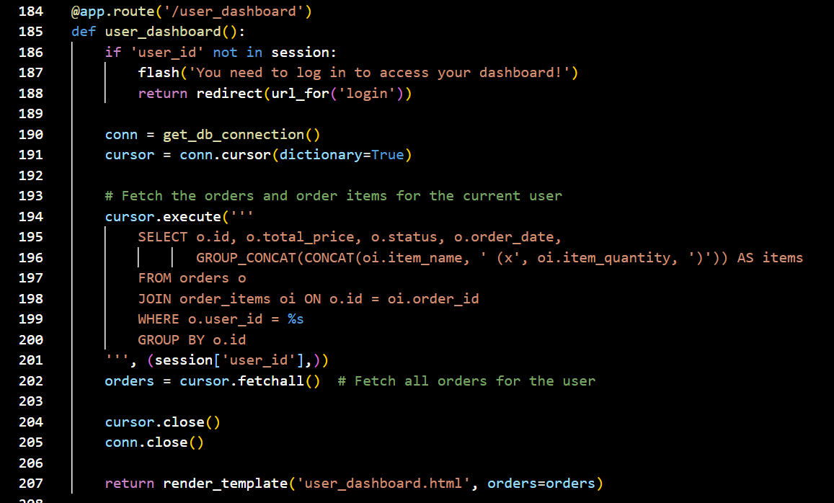

1. **Admin Dashboard (GET/POST)**: Allows admin to update order statuses and view detailed orders.

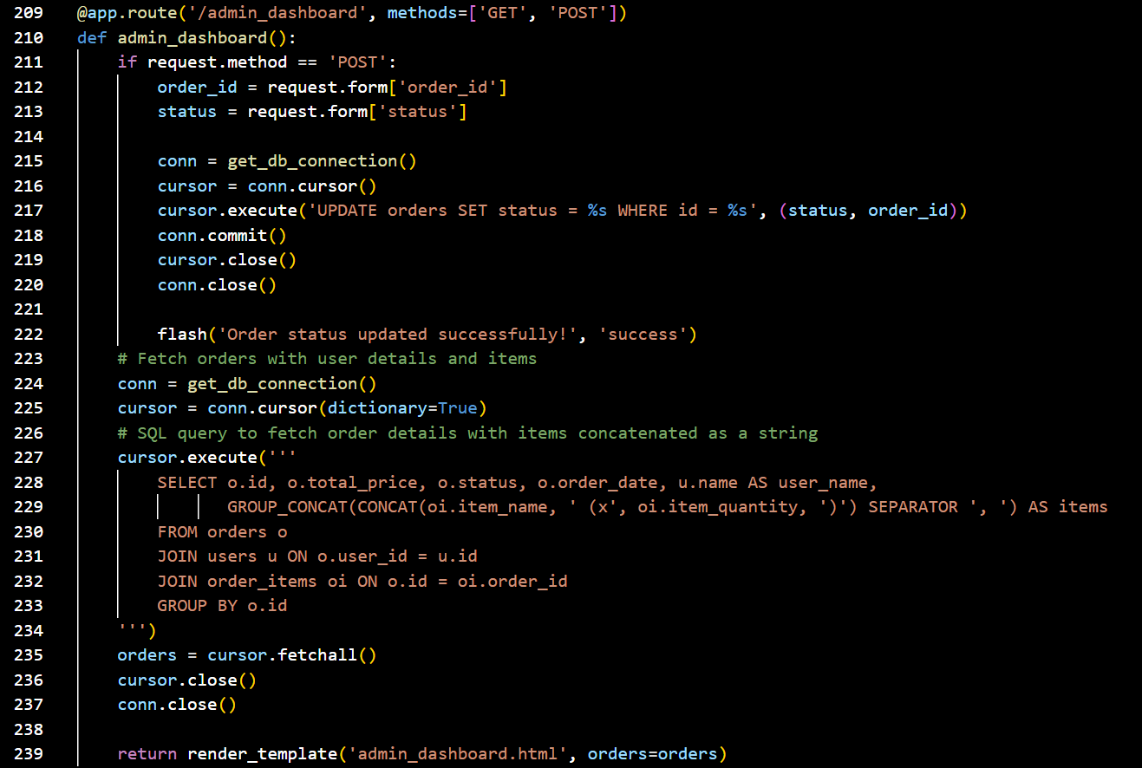

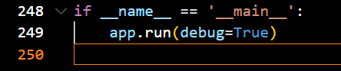

1. **Database Queries**: Uses SQL queries to interact with MySQL RDS for user and order data.
2. **Session Management**: Uses Flask session to store user and cart data for navigation.
3. **Error Handling**: Implements exception handling during order placement to ensure transaction safety.
4. **Order Status Update**: Admin can change order status, like “shipped” or “delivered.”
5. **Flash Messages**: Provides user feedback through flash messages for login, registration, and updates.
6. **Item Data Fetching**: Retrieves items from the database to display on the shopping interface.
7. **Group Concatenation**: Combines item names in orders for easy display on the dashboards.

**Milestone 4: EC2 Instance Setup**

* **Activity 4.1: Launch EC2 Instance**
  + Choose a Linux-based EC2 instance from the AWS Console to host the FreshBasket application.

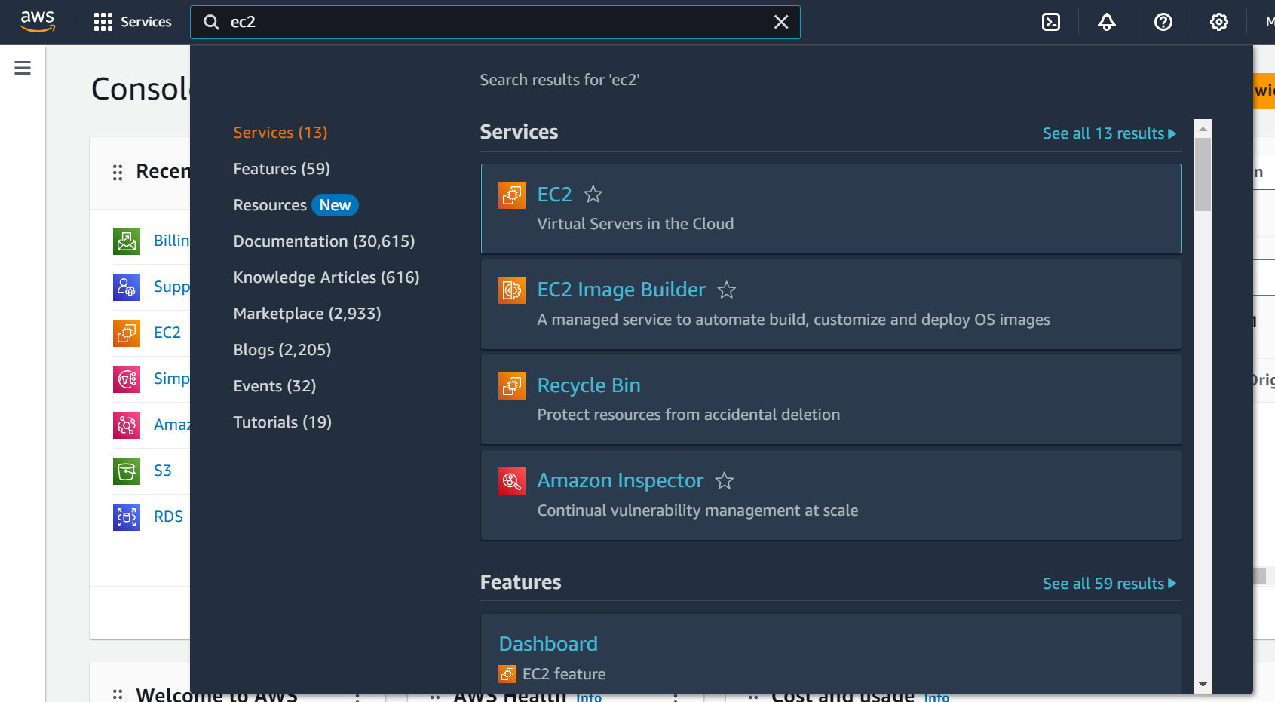

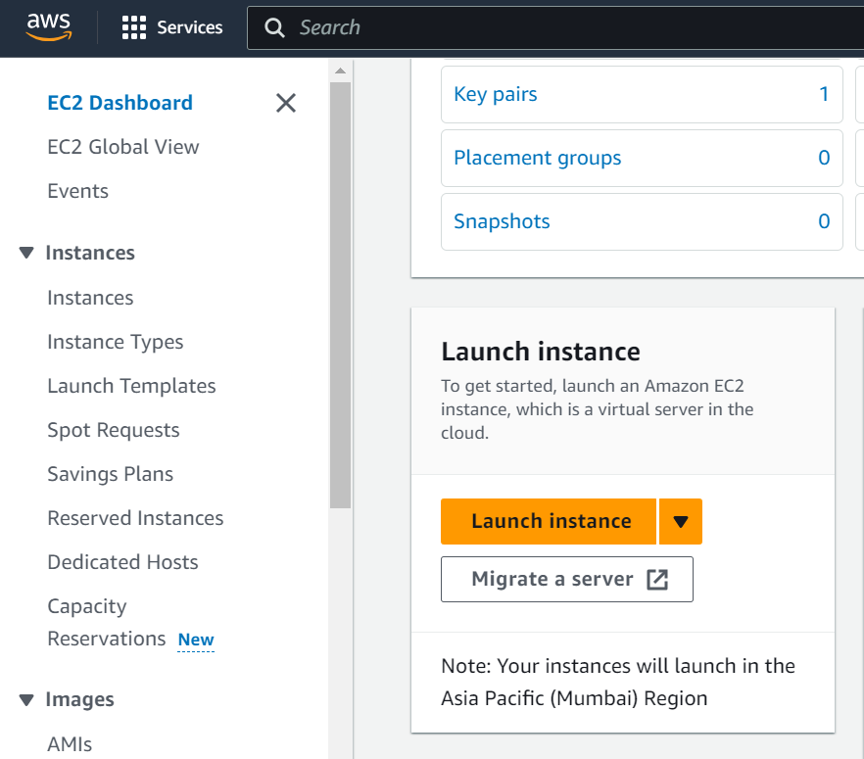

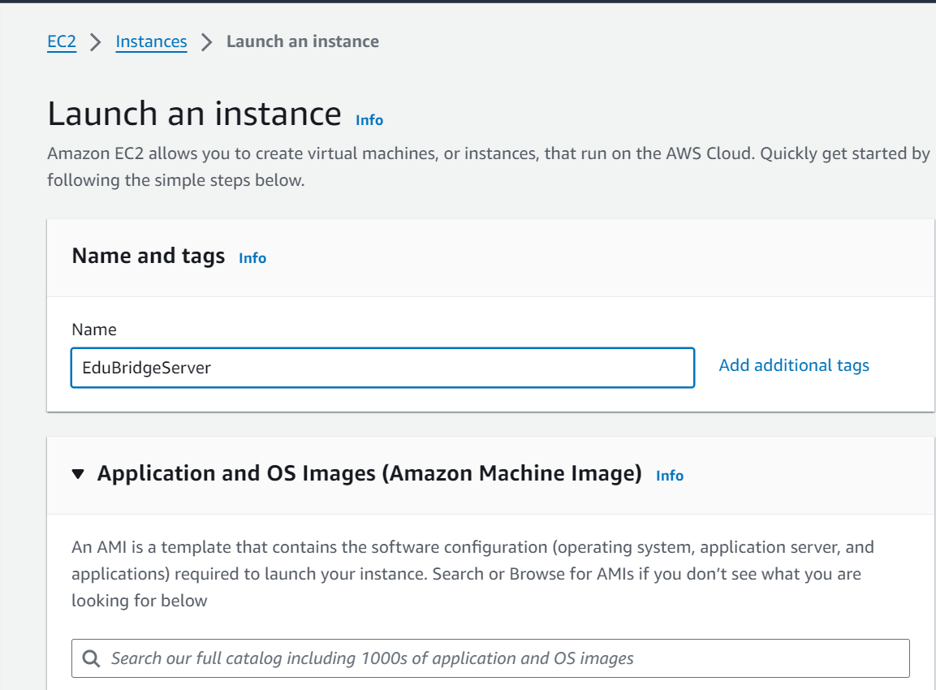

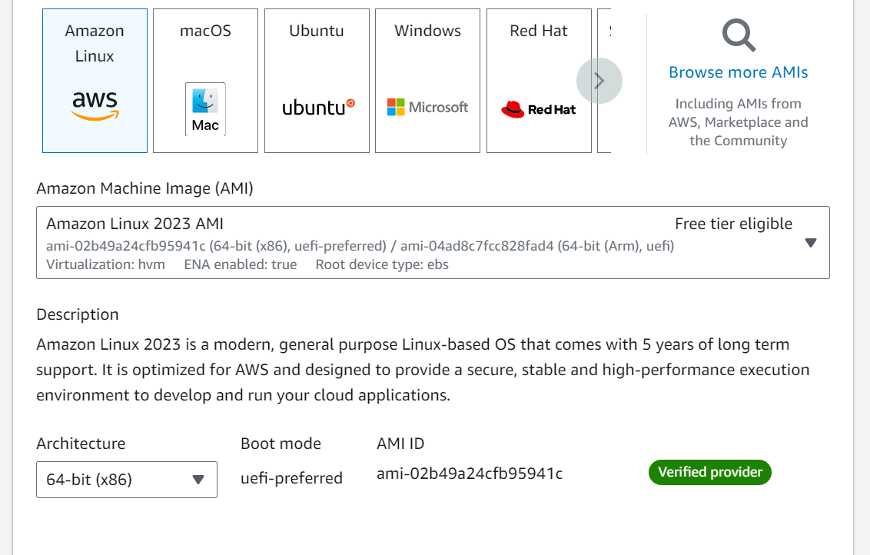

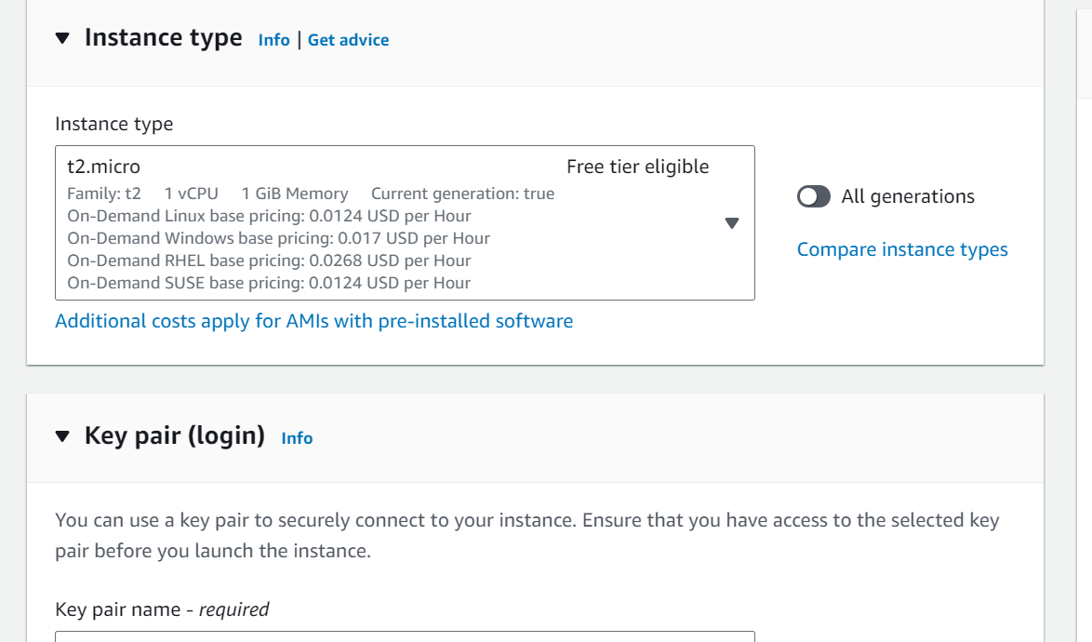

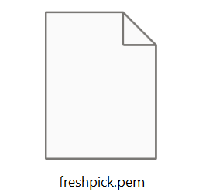

* **Activity 4.2: Configure Network Settings**
  + Set up the security group to allow HTTP, HTTPS, and SSH traffic.

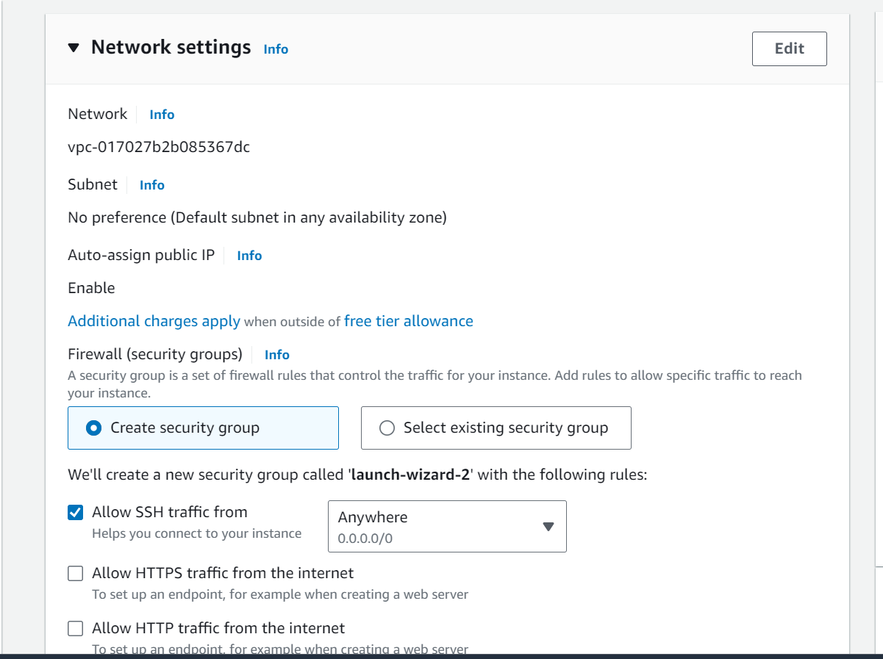

* + Create and download the key pair for SSH access.

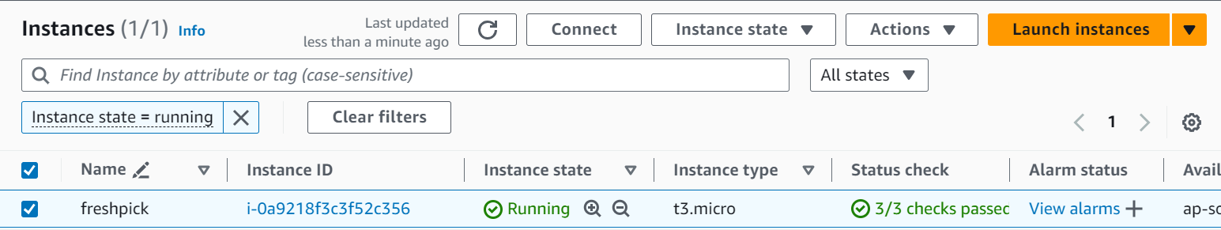

**Setting up Inbound and Outbound rules**

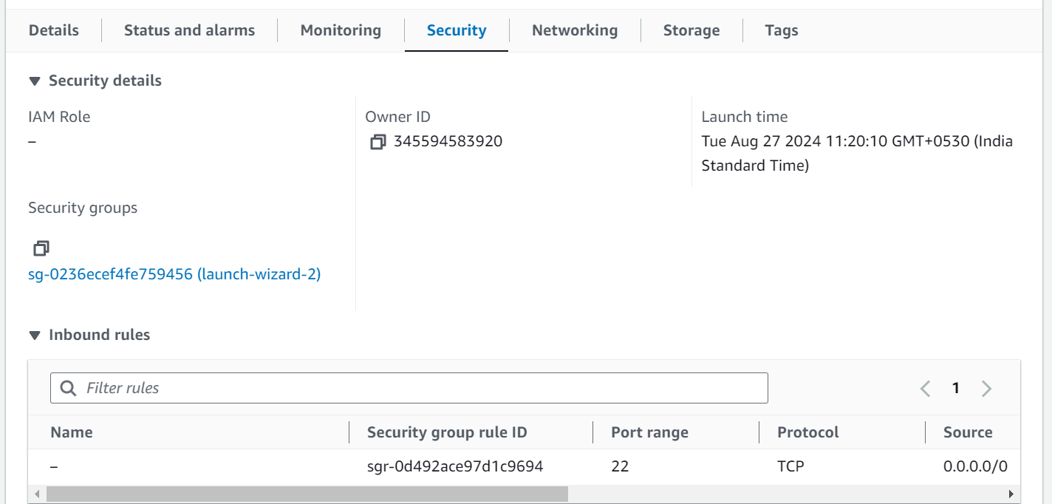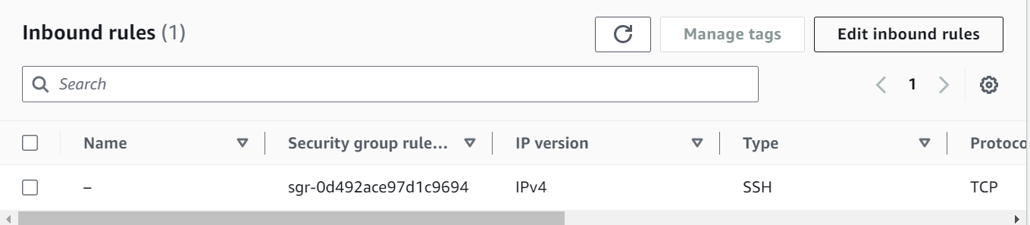

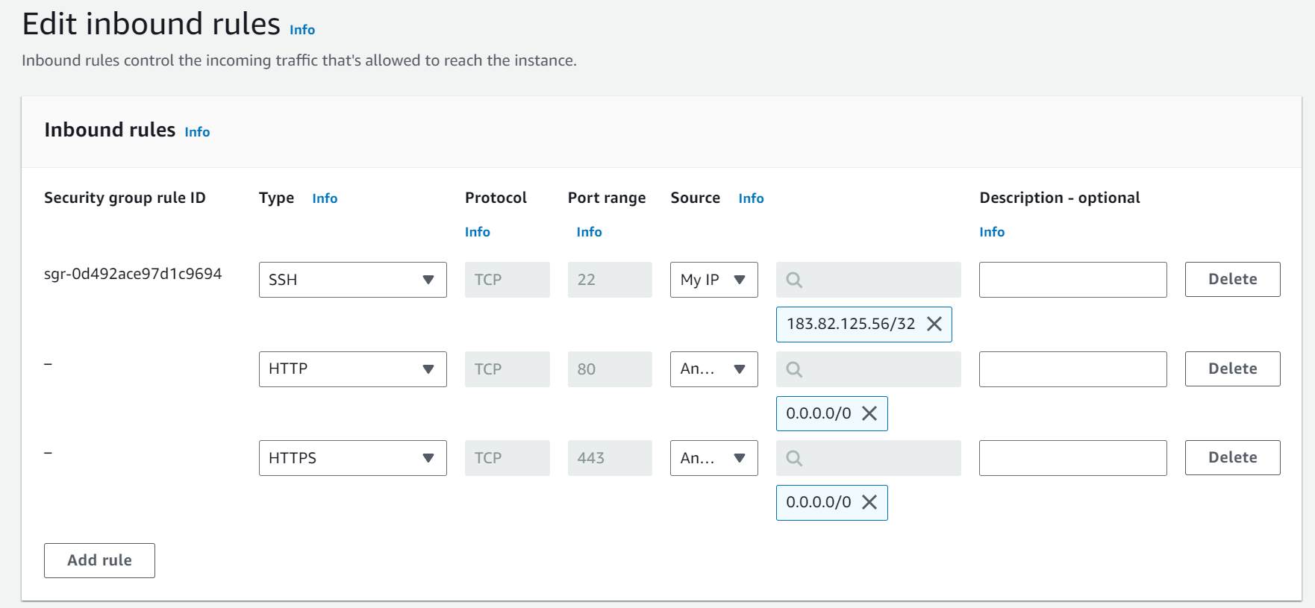

* Add Type : HTTP > Source : Anywhere
* Add Type : HTTPS > Source : Anywhere

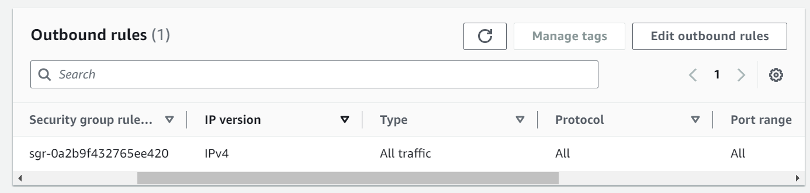

**Milestone 5: MobaXterm Setup and SSH Access**

* **Activity 5.1: Install and Configure MobaXterm**
  + Download and install MobaXterm on your local machine.
  + Establish an SSH session with the EC2 instance by uploading the .pem key file.

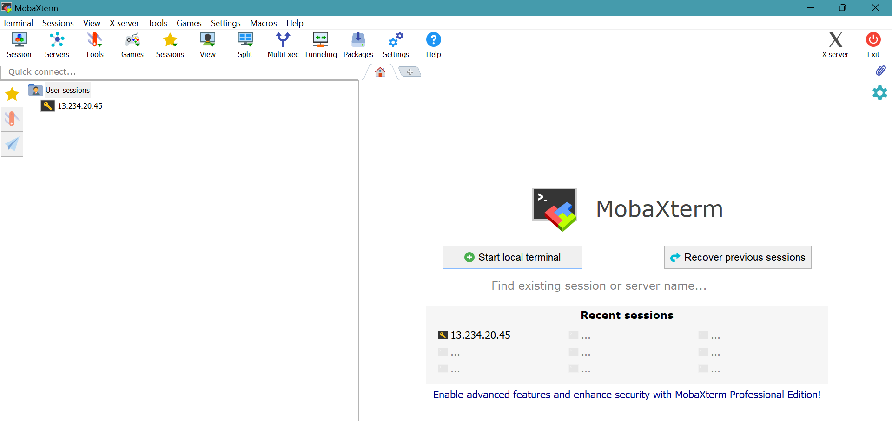

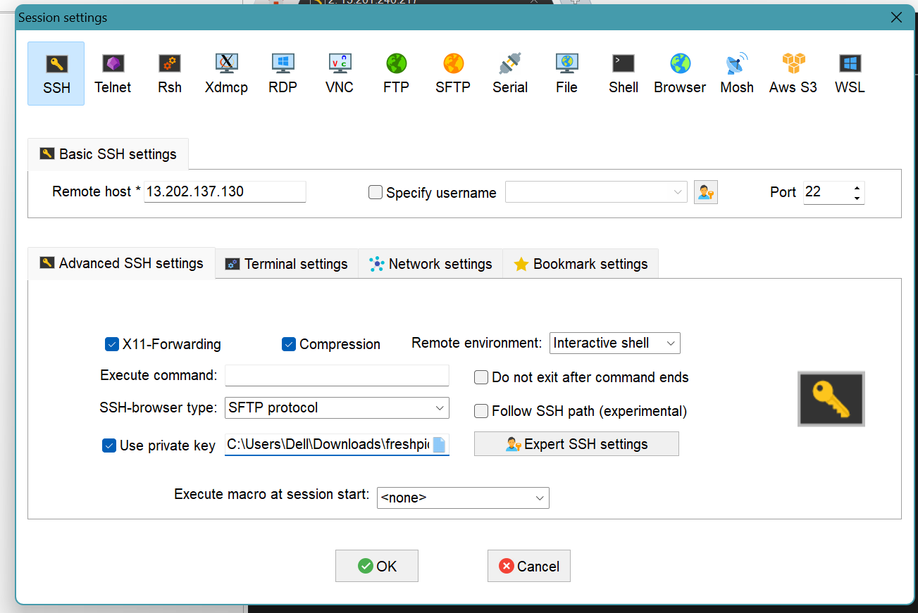

**Activity 5.2: Login into the SSH Session**

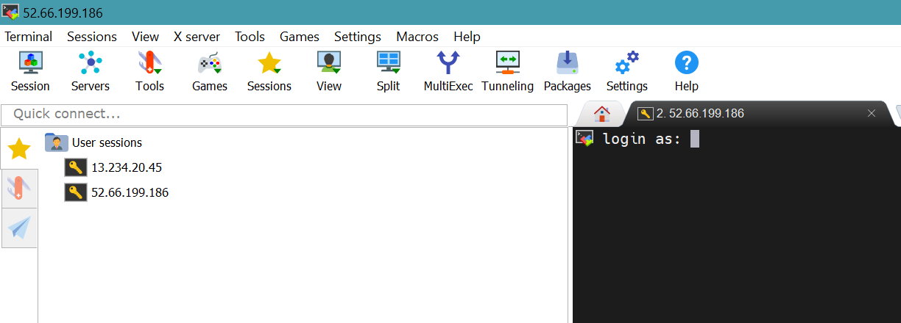

* Login as : ec2-user

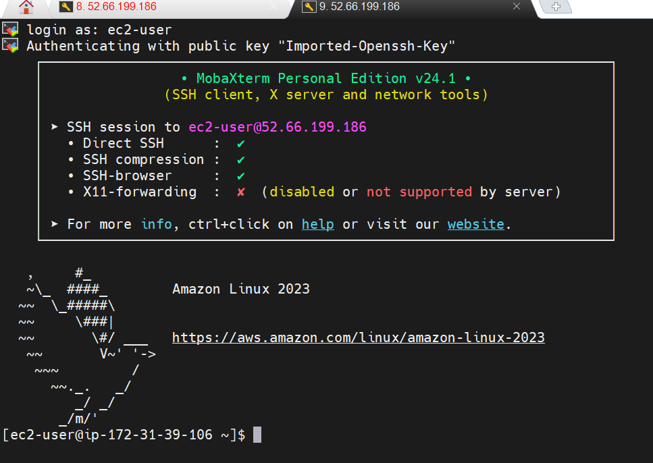

**Update and Install Web Server Software**

* Update package lists with sudo apt-get update (Ubuntu) or sudo yum update (Amazon Linux).

Install Apache or Nginx:

* For Apache: sudo apt-get install apache2 (Ubuntu) or sudo yum install httpd (Amazon Linux).
* For Nginx: sudo apt-get install nginx (Ubuntu) or sudo yum install nginx (Amazon Linux).

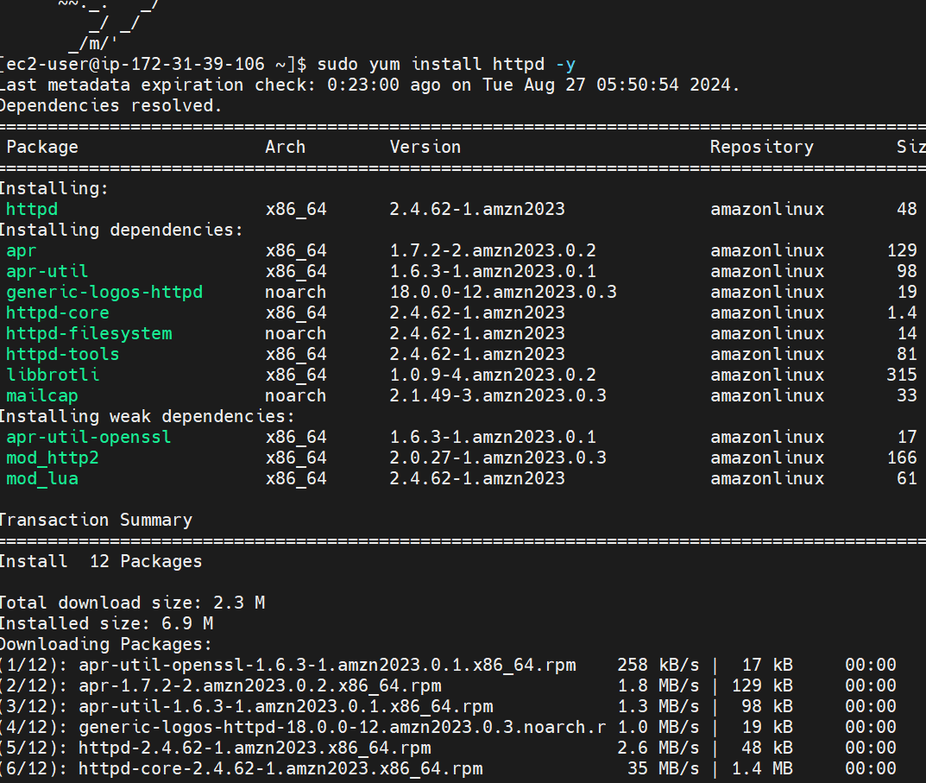

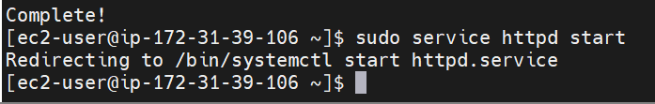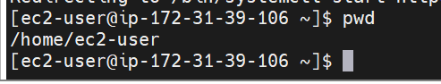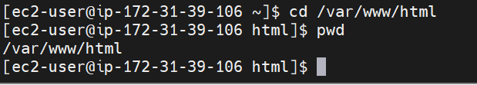

**Upload Website Files Using MobaXterm**

* Use MobaXterm’s SFTP functionality to transfer website files to the EC2 instance.
* Navigate to the /var/www/html directory (or the relevant directory for Nginx) and upload the files.



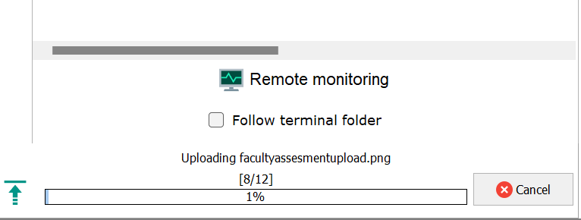

* **Activity 5.3 : Launch Flask Application**
  + Run the Flask app on the EC2 instance through the SSH session to serve the FreshBasket frontend.

**Milestone 6: Testing and Deployment**

* **Activity 6.1: Functional Testing**
  + Test the FreshBasket application for functionality, including database interactions and frontend features.
  + Run the Flask app **python3 app.py**
  + It will give you the link
  + 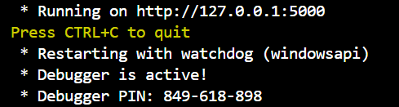
* **Activity 6.2: Deployment**
  + Deploy the application in a production environment, ensuring high availability and performance.

Click on the link above and it will take you to the webpage:

**home:  
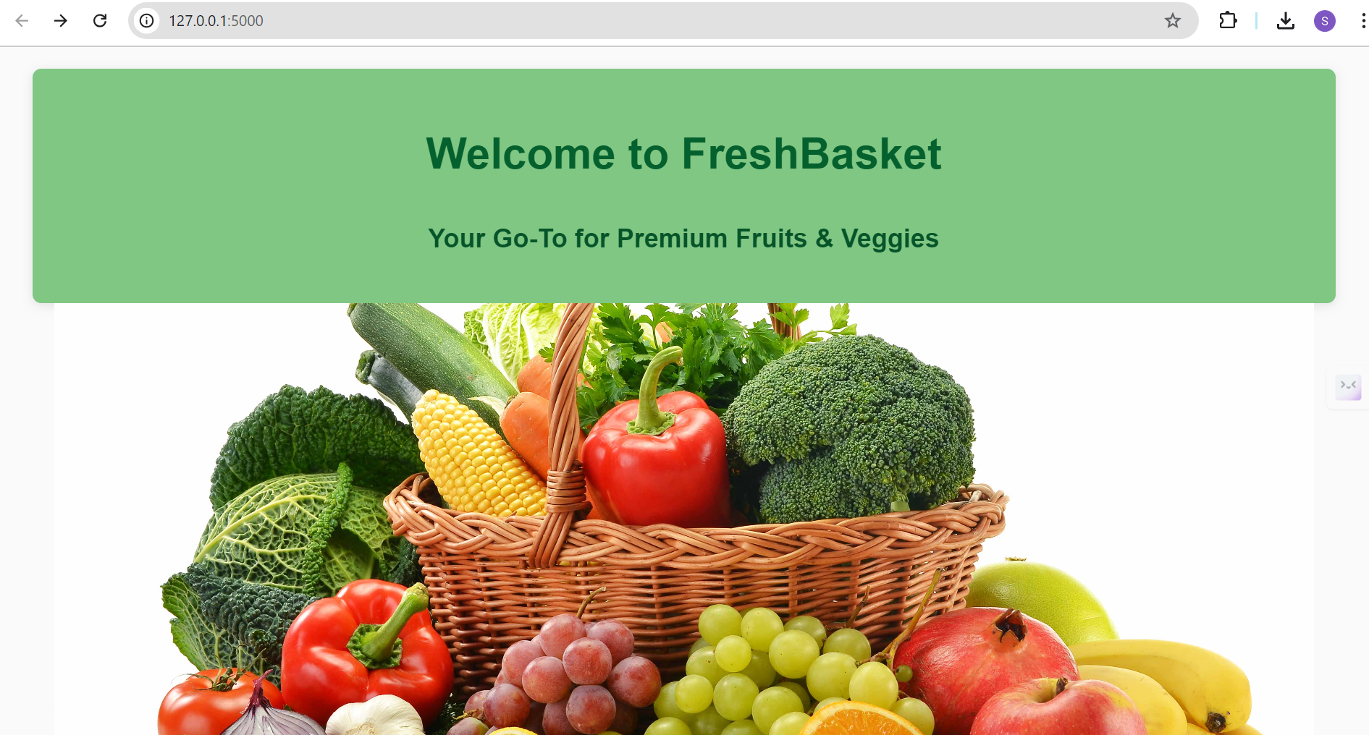**

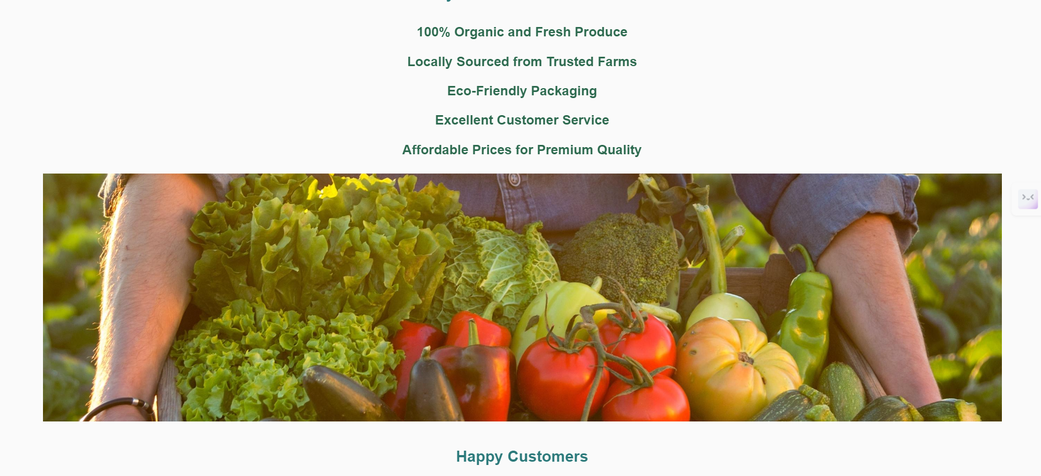

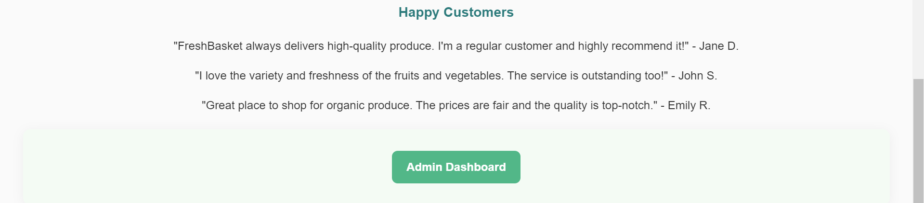

**Register:  
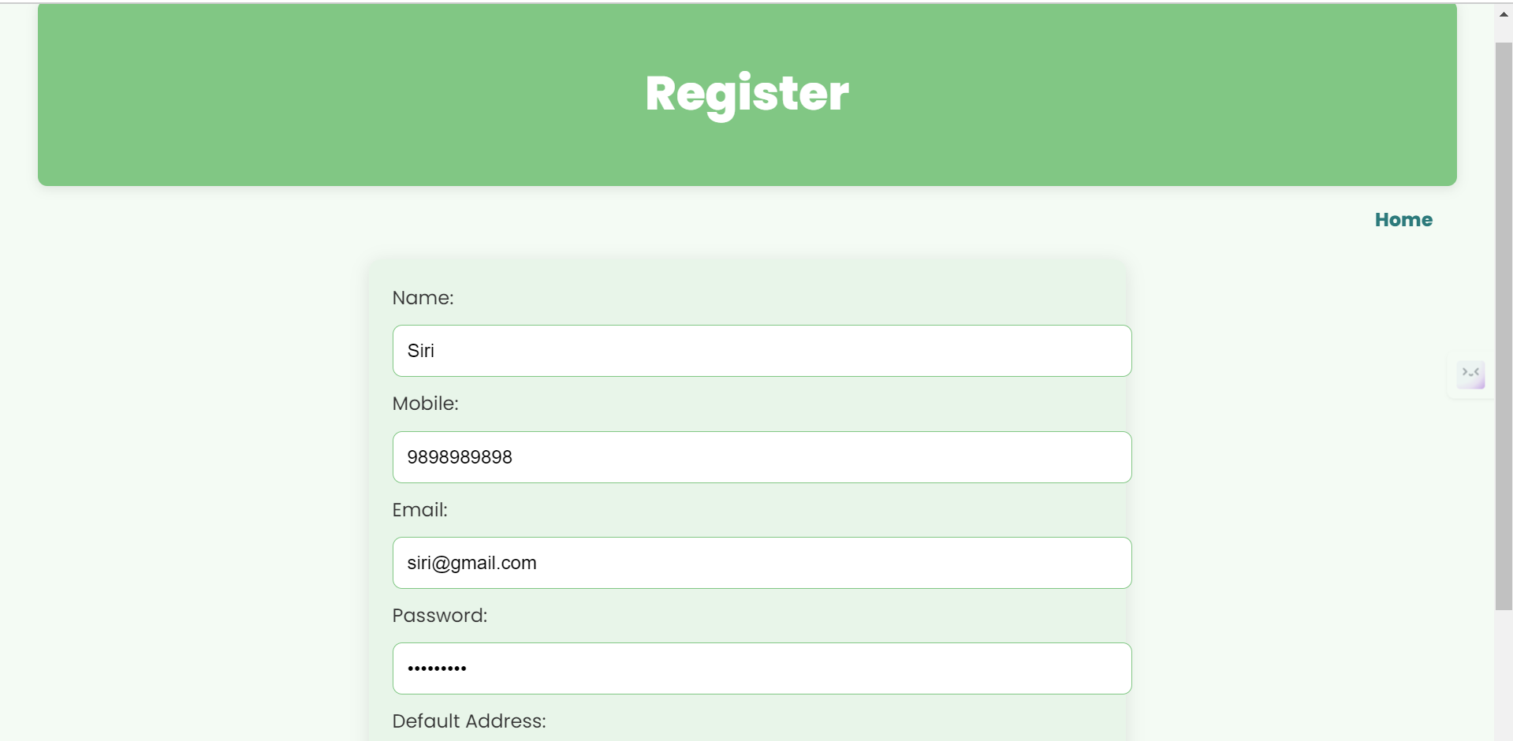**



**Login:   
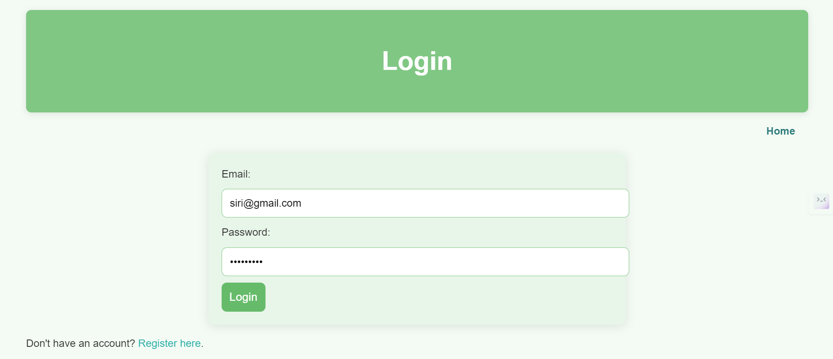**

**Shop :   
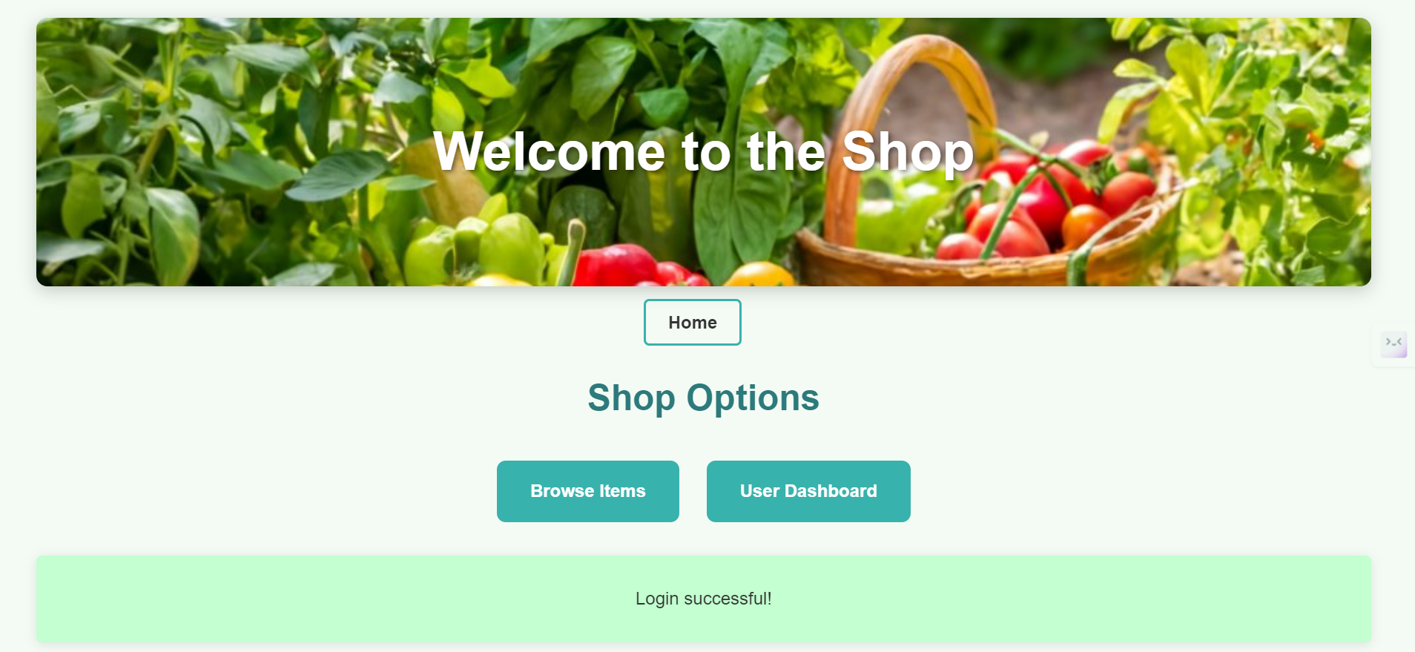**

**Items:**

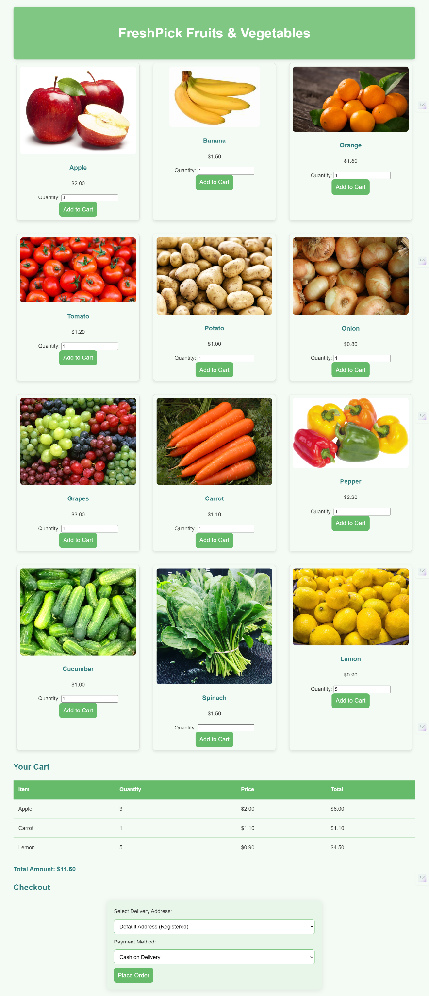

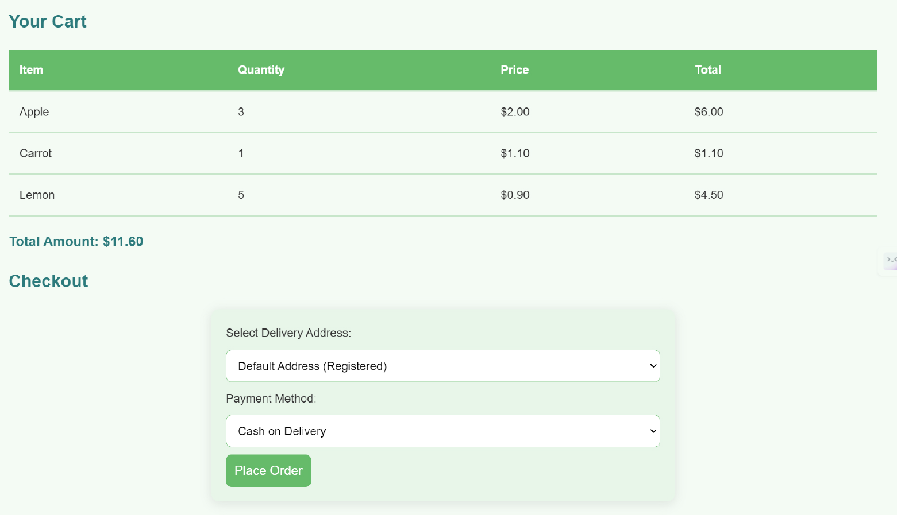

**User Dashboard:   
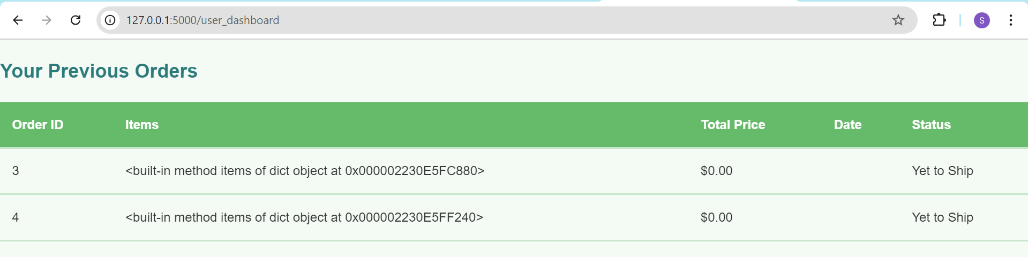**

**Admin Dashboard:  
  
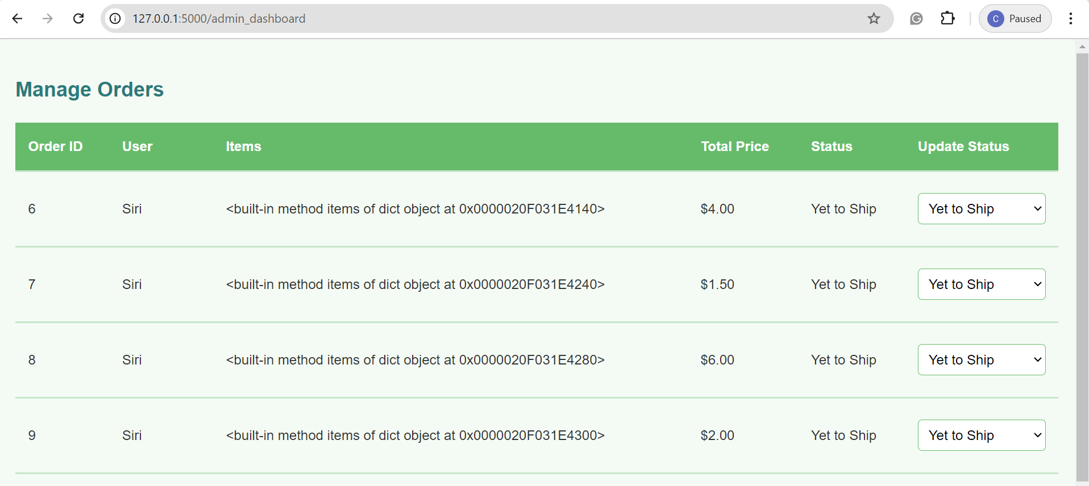**

* **Activity 6.3: Check the updations in the mysql database.**

**MySql Database updations :**

1. **Users table :   
   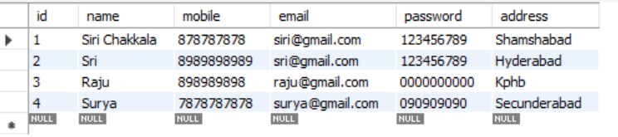**
2. **Orders table :**  
   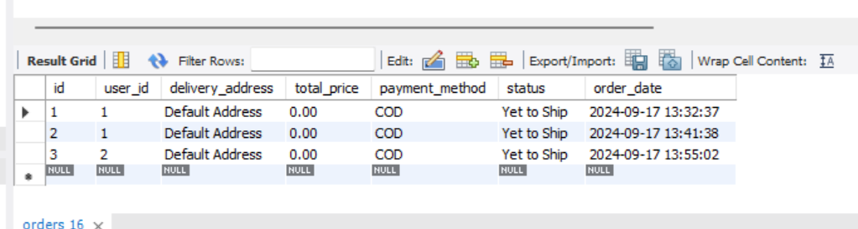
3. **Items table :   
   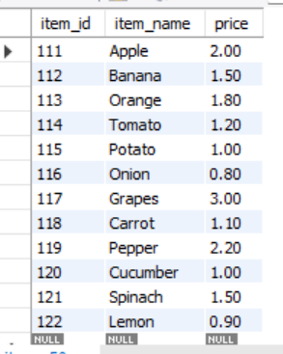**

**Milestone 7: Monitoring and Optimization**

* **Activity 7.1: Performance Monitoring**
  + Set up AWS CloudWatch for monitoring EC2 and RDS performance metrics.
  + Implement alerts and notifications for critical performance thresholds.
* **Activity 7.2: Optimization**
  + Optimize the server and database configurations based on monitoring results, including adjusting instance types and query optimization.

**Conclusion:**

The FreshBasket project showcases the deployment of a scalable and efficient e-commerce platform using AWS. By integrating Flask with MySQL RDS, it ensures smooth data management and secure backend operations. The EC2 instance, coupled with MobaXterm, enables seamless remote management and deployment of the application. From database setup to frontend development and deployment, each milestone was carefully executed to ensure reliability and performance. AWS CloudWatch is used to monitor performance and ensure smooth functioning. Overall, the project demonstrates the ability of AWS services to support dynamic, scalable web applications in real-world scenarios.